LCA Savills
Website Content
Clean, editable copy of every page on the live site

Website ref: LCA Savills -Supply chain and logistics consulting for Asia
Source: lcatest.vercel.app -transcribed from the live build (GitHub VaughansPersonalHub/lcatest, main @ commit 5bb8ba5, in sync with origin).
Generated: 22 June 2026.
Scope: All 13 pages plus shared navigation and footer. Body copy is reproduced verbatim from the site.
HOW TO USE THIS DOCUMENT
- Each page is a Heading 1 (red), with its URL beneath it.
- On-page section headings are Heading 2. Use the Table of Contents to jump around (right-click → Update Field to refresh).
- Grey small-caps labels (HERO, INTRO, CTA, FAQ) mark where copy sits on the page. They are guides, not website text.
- Edit the black text. [ Button ] marks call-to-action button labels; ↳ In-page link notes show where a link points.
- Bracketed notes such as [confirm-figure: …] are placeholders that already appear in the live site -fill these in or remove them.
Contents
Home 5
What we do 5
Independent, so the recommendation is yours 5
What that delivers, on recent projects 6
Warehousing, carried the whole way 6
Who we work with 6
Focussed on Asia 6
What clients say 6
Frequently asked questions 7
Services Overview 8
Ways to start working with us 8
Find the service that meets your need 8
What hands-on delivery looks like 9
Built-to-Suit Automated Warehousing, End to End 10
Where warehouse projects bleed money: the gaps between disciplines 10
Built country by country, because what is buildable changes at every border 10
Hire the full programme or a single workstream 11
What we deliver 11
Results from this work 11
Frequently asked questions 11
Supply Chain Network Design for Asia 13
What a network decision actually locks in 13
We work the landed cost to serve, not the rent 13
Independent, because we have nothing to sell you but the advice 13
What we deliver 14
How we work 14
Results from this work 14
Frequently asked questions 14
3PL Selection and Logistics Outsourcing in Asia 16
Decide what you are outsourcing before you run a tender 16
A single regional rate rarely survives contact with the floor 16
Stuck in a failing relationship? The contract could be the problem 16
How we work 17
3PL Selection options compared 17
Results from this work 17
Frequently asked questions 17
Transport & Last-Mile Optimisation 19
Where transport money leaks 19
The last mile is where cost concentrates and opinion forms 19
What we deliver 20
Transport options compared 20
Results from this work 20
Frequently asked questions 20
Inventory Optimisation & Forecasting (still to do) 22
Why over-buffering inventory costs you twice 22
Demand forecasting your planners will actually use 22
What we deliver 22
Results from this work 23
Frequently asked questions 23
Cost-to-Serve Analysis & Cost Reduction (still to do) 24
What cost-to-serve reveals 24
Rapid cost reduction: 12-week programmes 24
What we deliver 24
Results from this work 25
Frequently asked questions 25
Operational Excellence & Continuous Improvement (still to do) 26
What we look for in a warehouse diagnostic 26
Supervisor and team leader development 26
What we deliver 26
Results from this work 27
Frequently asked questions 27
M&A & Investment Support (still to do) 28
What we cover in supply chain due diligence 28
Post-merger integration support 28
What we deliver 28
Results from this work 29
Frequently asked questions 29
Results & Case Studies (still to do) 30
Case studies by sector 30
Sectors we work across 31
Where We Work 33
Malaysia Kuala Lumpur, Johor, Penang, Klang Valley 33
Singapore Jurong, Changi, Tuas 33
Thailand Bangkok, Laem Chabang, Chiang Mai 33
Vietnam Ho Chi Minh City, Hanoi, Da Nang 34
Indonesia Jakarta, Surabaya, Bekasi, Cikarang 34
Philippines Manila, Cebu, Clark 34
India Delhi, Mumbai, Chennai 35
Taiwan Taipei, Taoyuan 35
China 36
Cross-border corridors 36
Why LCA 37
Five reasons to work with LCA 37
How we stay independent 37
The team (still to do) 37
The Savills relationship 38
Contact (still to do) 39
Get in touch 39
Enquiry form 39
Site-wide elements (still to do) 40
Navigation bar 40
Footer 40

Home
/
HERO
Supply chain and logistics consulting for Asia
Sub-heading: Design, Build, Implement -working on your side of the table to cut cost and lift service across the region.
[ Button ] Talk to us
INTRO
LCA Savills is an independent supply chain and logistics consultancy working across Asia since 1999.
We cover network and inventory, warehousing procurement and 3PL, transport and last mile, cost-to-serve and operational excellence.
The people doing the work have run real operations. We earn our fee on advice, delivery and execution for the company that pays us, and we are willing to tie part of it to a measurable result.

What we do
- Network & Supply Chain Strategy -Where stock and capacity should sit within country and across the Asia region, and why.
- Warehousing, End to End -Design, build and commission a DC, from first site decision to go-live.
- Inventory & Forecasting -Service and working capital balanced to your real demand.
- Logistics Outsourcing & 3PL Management -Choose and contract logistics partners on terms that hold up.
- Transport & Last Mile -Lane, mode and route design that takes cost out without hurting service.
- Cost-to-Serve -What each channel, customer and SKU actually costs you to fulfil.
- Operational Excellence -Cost, capacity and service gains in facilities you already run.
- M&A Support -Supply chain due diligence and integration for deals and investors.

Independent, so the recommendation is yours
We do not sell buildings, 3PL contracts, software or automation. On a network study, a 3PL tender, an inventory fix or a warehouse build, the answer is the solution that is right for you.
We earn our fee on the advice and the delivery. Where we are responsible for execution, our fees Can be linked to the results.
Savills is our strategic shareholder, and we are independent so our clients get the best outcome. More on how we are set up.
↳ In-page link: “More on how we are set up.” → /why-lca

What that delivers, on recent projects
Metric | Result | Context
Transport cost reduction | 28% | FMCG manufacturer
Service level uplift | 24% | Beverage manufacturer
Storage capacity increase | 2.3x | Automotive client
[ Button ] See all results
↳ In-page link: “See all results” → /results

Warehousing, carried the whole way
A new distribution centre is where most of the risk sits, and where most consultants stop at a slide deck. We carry it from network and site decisions through the build, fit-out, racking, SOPs and training to a controlled go-live.
We stay client-side and accountable for whether the operation works. On a live automated build, that includes checking every vendor design change against the signed contract before you pay for it.
[ Button ] See how it runs
↳ In-page link: “See how it runs” → /services/warehousing-end-to-end

Who we work with
We work across FMCG, beverage, automotive, pharmaceutical, white goods, retail and private equity.
Our clients are manufacturers, distributors, retailers, logistics service providers and e-commerce players.

Focussed on Asia
We live and work all over Asia.
The rules differ in each country, from flood risk and truck-ban hours to island and ferry geography and land-tenure conditions.
We factor that in early, while you can still change the answer. Country-by-country detail.
↳ In-page link: “Country-by-country detail.” → /where-we-work

What clients say
“LCA sat on our side of the table for 18 months through design, build and go-live. The DC hit its numbers from week three. That does not happen by accident.” -Supply Chain Director, Regional FMCG Manufacturer
“They told us the 3PL contract was the problem, not the warehouse. They were right. A renegotiation and KPI reset fixed what two years of complaints had not.” -COO, Beverage Distributor, Thailand

Frequently asked questions
What does a supply chain and logistics consultant in Asia actually do?
It depends on the problem. We help you decide where stock and capacity should sit, balance inventory against service, take cost out of transport and last mile, select and contract 3PLs, and improve facilities you already run. We also design, build and commission distribution centres end to end. We do not operate your warehouse long-term.
Is LCA only a warehouse consultancy?
No. Warehousing end to end is our signature work, but it is one capability within a broader consultancy. We also cover network and supply chain strategy, planning and inventory, procurement and 3PL, transport and last mile, cost-to-serve, operational excellence and M&A support across Asia.
How is LCA independent across all of this?
We do not sell buildings, 3PL contracts, software or automation, so we have nothing to push. On a network study, a tender, an inventory fix or a warehouse build alike, the recommendation is the one that is right for you. Savills is a strategic shareholder that adds property and funding reach, and the independence is paramount.
Which countries in Asia does LCA cover?
We live and work in Asia. Core markets include: China, India, Indonesia, Japan, Malaysia, Philippines, Singapore, Taiwan, Thailand, and Vietnam. Local rules vary, so we factor land tenure, permitting and lease terms into the decision before anything is signed.
Will LCA link its fees to results?
Yes. We will put part of our fee against delivering a target we have set, such as a transport-cost or service-level gain.
CTA -CLOSING BAND
Tell us what is keeping your supply chain up at night
Sub-heading: We will tell you straight whether we can help.
[ Button ] Book a call

Services Overview
/services
HERO
Supply Chain & Warehouse Consulting SE Asia
Sub-heading: Client-side warehouse and supply chain consulting across Southeast Asia. Take the full menu or one piece. Start with a paid diagnostic.
[ Button ] Book a diagnostic

Ways to start working with us
There is no single front door. How we start depends on what you already know about the problem and how much certainty you need before committing budget. A short paid diagnostic is one common way in.
- Short paid diagnostic -A scoped review of your current position, the cost of it, and your realistic options. Days to a couple of weeks, fixed fee.
- Response to your RFP -You already know the scope and want proposals. We respond to RFPs and tenders on your terms.
- Single scoped piece -One defined task with a clear deliverable: a design review, a network study, or a build-readiness check.
- Full programme -From design through build to a facility running to its numbers, then handover.
- Fee partly at risk -Where the target is clear and measurable, we can tie part of our fee to the result.

Find the service that meets your need
- Network & Supply Chain Strategy -Where your stock should sit and how many sites, modelled against real demand and freight cost.
- Warehouse Design, Build & Commissioning -Concept and site selection through to a working building, including automation and contract scrutiny.
- Logistics Outsourcing & 3PL Management -Whether to outsource, to whom, and on what terms. Independent selection and contracting.
- Transport & Last Mile -Routing, mode, carrier mix and cost-to-serve, aimed at a lower bill that holds service. Success through better transport management and process redesign.
- Inventory, Forecasting & Planning -Stock levels, forecast accuracy and planning that frees cash without stockouts.
- Cost-to-Serve & Cost Reduction -Where the money goes and what to cut first. Activity-based cost analysis by customer, channel and SKU.
- Operational Excellence -More productivity and service from a site you already run, before you spend on new.
- M&A & Investment Support -Supply chain and property diligence for buyers and private equity.

What hands-on delivery looks like
You want your stock in the right place, at a competitive cost, without a two-year build pulling your team off the day job. We take that from concept and site selection to a working building: design, build, fit-out, automation procurement, testing and migration.
We stay until your people can run it without us. Full detail, including a live automated-DC build where we check every vendor design change against the signed contract, is on our warehousing page.
↳ In-page link: “warehousing page” → /services/warehousing-end-to-end

↳ In-page link: “Country-by-country detail” → /where-we-work
CTA -CLOSING BAND
Copy: Tell us the problem and we will tell you whether we can help and how.
[ Button ] Start a diagnostic

Built-to-Suit Automated Warehousing, End to End
/services/warehousing-end-to-end
HERO
Built-to-suit automated warehousing, end to end across Asia
Sub-heading: We find the site, get it funded and built, run the design and automation, and stay until your team can run it.
[ Button ] Book a site review
INTRO
You want the warehouse. You want it sized to your volumes, automated where possible, built to plan, and hitting its numbers from day one.
The risk is in getting it wrong: a design that does not fit how you operate, a build that runs late or over budget, automation that doesn’t pay back, and an operation that damages service.
LCA Savills designs, builds and commissions built-to-suit warehouses across Asia, working only on the client side to protect your interests throughout the process.
We find the site, source the funding where it helps, run the design process, procure the automation, stand up the operation, and stay with your team through go-live.
We work for you, not the property developer or the automation vendor. We do not run your warehouse long-term: we get it built and working, stay until your team can run it well, then hand over.

Where warehouse projects bleed money: the gaps between disciplines
A new DC touches site selection, design, automation, procurement, SOPs, shift design, training and migration. The gaps between those processes are where time and money leak.
Site selection sits with property people. Design goes to an engineering firm. Automation goes to a vendor whose interests are not yours. The rest lands on a client’s team who already have full-time jobs.
We hold the whole thing together and represent one interest, yours, from the first site shortlist to the day your team takes over a DC that hits its numbers.

Built country by country, because what is buildable changes at every border
"Asia" is a generic term. The work is country by country, because permitting, work styles, land tenure and labour rules change at every border and sometimes at every state line.
We know what is actually buildable on each shortlisted site before anyone commits, and we factor cross-border corridors when your network spans more than one market.
↳ In-page link: “Market-by-market detail” → /where-we-work

Hire the full programme or a single workstream
This is modular. Plenty of clients already have a developer and a building underway and just need the missing parts.
That might be the design engagement, the automation procurement, the SOPs and WMS requirements, or the training and migration plan. Or it might be a full design health check working collaboratively with your developer.
We scope to what you actually need, not a fixed package.

What we deliver
- Find -Shortlist and assess sites against your network, volumes and growth, with the local read on leasehold, zoning and permitting.
- Fund -Where it helps, we can source funding for a purpose-built facility so you do not tie up capital in property.
- Design -DC design sized to your throughput now and in the future, from conventional racking to full automation, with a defensible business case.
- Build and fit out -Manage construction, racking, MHE and automation install, holding contractors and vendors to the contract you signed.
- Go live —Team and shift design, SOPs, WMS requirements, training, testing and stock migration, so day one is boring in the best way.
- Stabilise -Stay through ramp-up, fix the issues, working collaboratively with your team.

Results from this work
Metric | Result | Context
Operating cost cut | 34% | Converting a site to semi-automation
Storage capacity | 2.3x | In the same footprint for an automotive client
↳ In-page link: “See all results” → /results
Related services: Supply Chain Network Strategy, 3PL Selection

Frequently asked questions
What does a client’s representative do on a warehouse project in Asia?
We manage the design, build and commissioning of your facility while representing only your interests. In practice that means pressure-testing the design, running procurement, and holding contractors and automation vendors to the signed contract, checking every change order before you pay for it.
What is a built-to-suit warehouse and how does it differ from leasing a spec-build?
A built-to-suit warehouse is purpose-built around your throughput, layout and automation, rather than a standard shed you adapt after the fact. Leasing an existing building is faster and cheaper up front but usually forces compromises on layout, automation choices, ceiling height and dock count. We help you weigh both honestly against your real volumes.
Can I hire LCA Savills for just part of a warehouse project?
Yes. The service is modular. If you already have a building and a developer, we can do the parts that are usually under-resourced, such as an independent design review, procurement, WMS requirements, training or stock migration. You can take the full programme or a single workstream.
Does LCA Savills run the warehouse after it is built?
No. Our role runs from site to go-live and stabilisation, then handover to your team.
How long does it take to design and build a distribution centre in Asia?
It depends on whether you are fitting out an existing building or doing a built-to-suit, and on local permitting, which varies by country and site. A fit-out can take months; a purpose-built facility runs longer once you factor in land, zoning and construction. Overall, it can take up to 2 -3 years. The honest answer comes after the site assessment.
CTA -CLOSING BAND
Copy: Tell us where you are starting from and what you need. We will tell you straight what we would do.
[ Button ] Book a site review

Supply Chain Network Design for Asia
/services/supply-chain-network-strategy
HERO
Supply Chain Network Design for Asia
Sub-heading: Where to put your plants, stock and DCs across the region, and how product should flow from source to customer.
[ Button ] Talk to us about your network
INTRO
A network decision sets your fixed cost and service levels for years. Get it right and you carry less stock and pay less freight; get it wrong and you are stuck with unnecessary fixed costs.
We model the trade-offs and tell you where stock should sit, how many DCs you actually need, and how product should flow from source to customer.
We have done this work across the region since 1999.

What a network decision actually locks in
A network is a set of decisions: how many sites you run, where they sit, how big each is, and which markets each one serves.
The decisions are physical once made. A lease signed and racking bolted to the floor are hard to walk back, so the cost of getting it wrong runs for years.
Designing a network involves making decisions such as network resilience, speed to customer, fixed versus variable cost commitments, stock holding alternatives, and the supporting technology. And designing a pan-Asian network can make these decisions even harder than a single-country network. For example, a DC in Johor serving Singapore and Thailand crosses borders that each carry their own duties, documentation and clearance times.

We work the landed cost to serve, not the rent
You decide where to put a DC by demand location and total cost to serve, not by rent per square metre.
A node that looks cheap on rent loses that edge the moment you add freight costs, transport delays and the buffer stock you hold to cover it. So we model the total cost to serve for each option along with the qualitative factors that are important to making the network work.
↳ In-page link: “We cover those market specifics” → /where-we-work

Independent, because we have nothing to sell you but the advice
Our advice is unconflicted because we do not sell buildings, 3PL contracts, software or automation.
When the strategy points to a new facility, our parent group Savills can find or fund a purpose-built site, or we work just as readily with property partners you already use.
↳ In-page link: “More on how that independence works” → /why-lca

What we deliver
- Network design and footprint -How many sites, where, and how big, based on where demand really is and what each location costs to serve.
- Distribution network strategy -Central versus regional DCs, what to hold where, and how stock moves between nodes.
- Route to market -How product reaches each channel and customer type, and where you are leaving service or margin on the table.
- Supply chain diagnostics -A hard look at the current network to find the cost and service you are losing today.
- Scenario modelling -Run the options before you commit capital, including growth, new markets, and a plant or DC move.
- Business case development -A board ready financial justification showing the benefits, costs, capabilities required, and implementation roadmap.

How we work
- Demand baseline -Build the real picture of where your volume sits today and where it is heading.
- Cost-to-serve model -Landed cost for each location and lane, lead times included.
- Scenario testing -Run the footprint options against demand and service targets.
- Recommendation -The recommendation, the numbers behind it, and what shifts if volumes move.
- Execution -If the decision requires support to execute, we can help.

Results from this work
Metric | Result | Context
Transport cost reduction | 28% | For an FMCG manufacturer, by fixing flow and stock placement
↳ In-page link: “See all results” → /results
Related services: Warehousing, End to End, Cost-to-Serve

Frequently asked questions
How do I decide where to locate a distribution centre domestic or regional in Asia?
Start with where your demand sits and the full cost to serve each location, not the rent. Factors such as transport cost, network security, lead time to customers, service standards are all factors which influence location -not just the cheapest square metre.
How many distribution centres do I need?
Usually fewer than most companies assume. Every extra DC adds fixed cost and splits your inventory, so each one has to earn its place by cutting freight or improving service enough to justify it. We model central versus regional structures against your real demand, then recommend the number that holds up if volumes come in higher or lower than plan.
Will you recommend a building you also profit from selling?
No. Our fee does not change with which site you pick, so we have nothing to gain by steering you to one property over another. The recommendation rests on the model and the numbers.
Do cross-border duties and lead times really change the network answer?
Often, yes. A node that looks cheap can lose its edge once you add customs delays and the safety stock you hold to cover them. Duty treatment between markets, free-zone status and clearance reliability all feed into where stock should sit. We build these into the model rather than treat them as a footnote, because in this region they routinely decide the outcome.
CTA -CLOSING BAND
Copy: Tell us where you are starting from and what you need. We will tell you straight what we would do.
[ Button ] Talk to us about your network

3PL Selection and Logistics Outsourcing in Asia
/services/logistics-outsourcing-3pl
HERO
3PL selection and logistics outsourcing in Southeast Asia
Sub-heading: We help you pick the right 3PL, write a contract that holds up, and fix the relationship when it goes wrong. No 3PL pays us a fee.
[ Button ] Talk to us about your 3PL
INTRO
You want the outsourcing decision to suit how you actually operate. The wrong call gets expensive fast: a provider that underprices the labour, a contract you cannot get out of, a service level that drops in your first peak.
The job is to buy the right scope, on terms that hold, from a provider who can run your volumes day to day, not just win the tender.
LCA Savills is an independent logistics outsourcing consultant working across Asia. We run the full sequence with you, from needs assessment to a steady operation, and no provider funds the recommendation you act on.

Decide what you are outsourcing before you run a tender
The real question is what you are buying, not who is cheapest. Plenty of companies outsource transport and keep the warehouse in-house; plenty do the reverse.
Some volumes and service profiles do not suit a shared-user 3PL at all, so a dedicated site makes more sense. Shared-user means you share space, labour and equipment with other shippers. Dedicated means a site run only for you.
We map your network, volumes and service requirements against your cost base first. Skip that and every quote answers the wrong question.

A single regional rate rarely survives contact with the floor
Where you outsource changes what a sensible rate looks like. In Southern Malaysia you weigh mature warehouse stock against tighter labour supply; in other parts of Malaysia the land and cost picture reads differently again.
Vietnam brings its own labour and holiday rhythm, with Tet cover the assumption providers most often underprice. Thailand adds flood-season planning and inner-cit y truck-ban hours.
We build these market realities into the brief and cost model.
↳ In-page link: “Full market detail by country” → /where-we-work

Stuck in a failing relationship? The contract could be the problem
When cost, service or trust has broken down, we come in as the independent party and work out what is actually wrong. It is often the contract rather than the operation. We help reduce your cost by helping reduce the costs of your supplier.

On one engagement the provider was hitting every SLA in the agreement, yet the client was still losing customers, because the SLAs measured the wrong things. The fix was a renegotiation and a KPI rewrite, not a re-tender.
Sometimes the answer is a managed exit and a fresh selection. Either way we represent you in the room, with the cost and service data to back what we ask for.

How we work
- Define the scope -What you outsource, and what good service looks like.
- Build the brief -Map network, volumes and service levels into a single comparable brief.
- Run the tender -Issue the RFP and run a structured process to a fixed timeline.
- Design the cost model -Structure bids so they are comparable, not just cheap on the surface.
- Shortlist on evidence -Live site visits and reference checks with operators who have run a peak.
- Negotiate the contract -Lock scope, pricing, KPIs and the exit clause before signature.
- Run the transition -Plan cutover, then govern performance after go-live.

3PL Selection options compared
Model | Tends to win when | Watch out for
Shared-user 3PL | Variable volumes, seasonal peaks, multi-client cost sharing | Less control over space and labour priority during peaks
Dedicated 3PL | Stable high volumes, specific compliance or brand requirements | Higher fixed cost; you may pay for capacity you do not always fill
In-house | Full control needed, proprietary processes, high volume density | Capital investment, recruitment and retention, technology risk

Results from this work [Check required]
Metric | Result | Context
Service level improvement | 24% | At no extra cost for a beverage manufacturer
↳ In-page link: “See all results” → /results
Related services: Warehousing, End to End, Transport & Last Mile

Frequently asked questions
How do I choose the right 3PL in Asia?
Define what you are outsourcing and what good service looks like, then take a structured brief to market so bids compare on cost and service, not just headline price. Watch out for ‘add-on costs’. Work collaboratively with vendors to find ways to reduce cost. Discussion matters. Shortlist on evidence: visit the warehouses the provider really runs, not the showcase site. Check references with operators who have been through a peak.
How long does a 3PL tender take in Asia?
A structured tender usually runs 10 to 14 weeks from finalising the brief to signing, depending on how clean your data is and how many providers you shortlist. Add transition time on top. Rushing the front end is a false economy, because gaps in the brief surface later as variation orders and disputes. We ensure the 3PL can deliver operationally what they promise in the tender response.
What should a 3PL contract include?
Scope defined down to the activity, a pricing model that survives volume swings, KPIs both sides can measure from real data, a review that forces year-on-year improvement, and a clean exit clause. The exit is the part most contracts skimp on and the part that gives you leverage when you need it.
Our 3PL relationship is failing. Do we have to re-tender?
Not always. The fix is often a renegotiation and a reset of the KPIs rather than a full re-tender, especially when the contract or the data is the real problem rather than the operation on the floor. We diagnose what is broken first, then represent you in the room with the numbers.
Are you affiliated with any 3PL providers?
No. We take no referral fees and run no provider panel, so we have no reason to steer you toward any particular 3PL. LCA represents the client, never the provider. That independence is the whole point of bringing in an outside consultant for selection and contracting.
What is the difference between open-book and fixed-price 3PL pricing?
Open-book means the provider shows you the real cost lines and you pay an agreed management margin on top, so you see where your money goes. Fixed or closed-book means one agreed rate and the provider carries the risk if costs move. Open-book suits volatile or growing volumes; fixed suits stable, well-understood operations.
CTA -CLOSING BAND
Copy: Tell us where you are starting from and what you need. We will tell you straight what we would do.
[ Button ] Talk to us about your 3PL

Transport & Last-Mile Optimisation
/services/transport-last-mile
HERO
Transport & last-mile optimisation across Asia
Sub-heading: Move goods for less, with better service, from line-haul through distribution to the last drop.
[ Button ] Book a transport health check
INTRO
You want your transport network to deliver on time, hit the service promise and cost no more than it should. Most of the overspend is invisible from the top, buried in routes and contracts nobody has reopened in years.
Get it wrong and the cost is real. You pay too much for drops, run fleet you do not need, and carry rates set for a market that has moved on.
We find that money and take it out while protecting service. We start in the data you already have: actual delivery points, drop sizes, order frequency and what your trucks do all day. That is where the cheapest savings hide.

Where transport money leaks
Most transport spend is set long before a truck moves. Routes get built years ago and never revisited. Delivery frequencies go unquestioned, so a customer gets three small drops a week when one full one would do.
Rates are the other leak. Many contracts were locked in when fuel and labour sat at different levels, and nobody reopened them.

The last mile is where cost concentrates and opinion forms
The last mile holds most of your delivery cost and shapes what the customer thinks of you. In dense cities, congestion and access limits point to smaller vehicles on time windows, plus a forward stocking point closer to demand.
Rural and island delivery flips it: long hauls, thin volumes, and a regional carrier base you manage closely. We design the model around your goods, your margins and the service promise you have made.
We do not run the fleet for you long-term. We get the model designed, the contracts signed and the operation working, then your team takes it over.

What we deliver
- Route optimisation -Built on your real drop data, so you stop paying for kilometres you do not need.
- Fleet design and sizing -Own, lease, contract or a mix, with the right vehicle matched to each lane.
- Freight benchmarking -Rate analysis that tells you which lanes are overpriced before you face the carrier.
- Carrier and 3PL negotiation -We run the rate conversation with you holding the pen.
- Last-mile models -Built for dense urban runs and scattered rural drops alike.
- Call-frequency restructuring -Fewer drops, with the service the customer actually notices protected.

Transport options compared
Fleet Model | Best For | Risk
Owned fleet (prime mover and trailer) | High density routes, brand-critical delivery experience | Fixed cost, asset depreciation, driver management
Owned trailer fleet only | High density routes, invest lower capital, technology and labour | Availability to service at critical times
Dedicated contracted carriers | Variable volumes, regional reach, speed to implement | Service consistency, rate volatility at renewal
Shared contracted carriers | Variable volumes, peak and seasonal flexible capacity | Ability to secure service at critical times
Hybrid (own + contract) | Core volume owned, peak and remote areas contracted | Complexity in planning and management

Results from this work [Check required]
Metric | Result | Context
Transport cost reduction | 28% | For a regional FMCG manufacturer
↳ In-page link: “See all results” → /results
Related services: Cost-to-Serve, 3PL Selection

Frequently asked questions
How much can transport costs realistically be cut in Southeast Asia?
Double-digit savings are common when routes and delivery frequencies have drifted for years. The biggest gains usually come from drop frequency and fleet sizing, not squeezing carrier rates alone.

Should we run our own fleet or use a 3PL or mix?
It depends on drop density, service requirements and how much control you need. Dense urban routes with high volume often suit an owned fleet. Scattered or seasonal delivery usually suits a contracted or hybrid model. We model both options on your actual data.
CTA -CLOSING BAND
Copy: Tell us where you are starting from and what you need. We will tell you straight what we would do.
[ Button ] Book a transport health check

Inventory Optimisation & Forecasting
/services/inventory-forecasting-planning
HERO
Inventory optimisation and demand forecasting in Asia
Sub-heading: Get your inventory levels right for how you actually run. Service improves, working capital comes down, storage needs reduce and you stop paying for stock that hides problems you could fix instead.
[ Button ] Talk to a senior operator
INTRO
Most inventory problems are not solved by holding more stock. They are solved by sizing safety stock to the demand variability and lead times you actually have.
Then by sorting your SKUs so that fast and slow lines have different rules applied, and positioning stock across your network instead of holding everything everywhere. Cross dock and flow through options should also be considered.
LCA Savills does this work across Asia. We have the analytical skills and practical operational experience to make this work for you.

Why over-buffering inventory costs you twice
Safety stock has a job: it absorbs the variability you cannot predict. The trouble is that most businesses set it once and never review it as suppliers and demand change, so it creeps up. You pay for that buffer in working capital, warehouse space and inefficiencies.
You pay a second time because it hides what you should be fixing: a weak forecast or a supplier who is often late. A supplier who is inconsistent in their on-time and in-full performance looks ok when you are holding additional stock to cover the issue.
Strip the buffer back to what the data justifies. You usually free up cash and expose the lead-time and forecast problems worth fixing.

Demand forecasting your planners will actually use
A forecast only helps if the planning team trusts it and acts on it. We look at what drives your demand, which SKUs are forecastable and which are not, and where promotions, seasonality or a few big customers distort the picture.
Then we build a forecasting approach matched to that reality, set accuracy targets that mean something, and put a practical review cycle in place so the number improves instead of drifting. The aim is not a complex model. It is a trusted process to deliver numbers people believe in which then drives actions the business commits to.

What we deliver
- Demand forecasting -Statistical models tuned to your data, not software defaults.
- Inventory policy design -Safety stock, reorder points and target levels by SKU and location.
- S&OP process -Design that gets sales, supply and finance talking based on agreed numbers
- SKU segmentation -ABC analysis that reflects your real cost-to-serve, not just volume.
- Working capital release -Quantified cash impact before we start implementation.

Results from this work [Check this]
Metric | Result | Context
Service level uplift | 24% | At no extra cost for a beverage manufacturer
↳ In-page link: “See all results” → /results
Related services: Supply Chain Network Strategy, Cost-to-Serve

Frequently asked questions
How do you reduce inventory without hurting service?
We size safety stock to the variability you actually see, not a textbook formula. Then we segment SKUs so that fast lines get tighter control and slow lines get less attention. Positioning stock closer to demand reduces lead-time exposure or consolidating slow moving SKUs are two options of many. The result is usually both lower inventory and better service.
How long does an inventory project take?
A typical engagement runs 3 to 4 months: data gathering and analysis in the first 6 weeks, policy design and validation in weeks thereafter, and implementation can start once the solution is agreed. We stay until the new policies are running and your team is confident.
Do we need new software?
Usually not. Most inventory improvements come from better policy, segmentation and process, not new technology. If your current system genuinely cannot support what you need, we will say so and help you specify requirements without favouring any vendor.
CTA -CLOSING BAND
Copy: Tell us where you are starting from and what you need. We will tell you straight what we would do.
[ Button ] Talk to a senior operator

Cost-to-Serve Analysis & Cost Reduction
/services/cost-to-serve-cost-reduction
HERO
Cost-to-Serve: see what each customer really costs you
Sub-heading: We build a detailed cost model that loads logistics cost onto every order, customer and product, then show you where to cut without hurting service.
[ Button ] Book a cost-to-serve review
INTRO
Most companies know their average cost per case or per kilo. What they do not know is which customers, channels and SKUs are profitable once logistics is loaded on properly.
The answer is often uncomfortable. A customer, a category, or SKU that looks good on revenue or gross margin can be destroying value once you add the cost of small orders, distant delivery and frequent returns.
We build a cost-to-serve model from your actual operational data -warehouse labour, transport, inventory holding and order management -allocated to customers and products by the activities that actually drive cost.

What cost-to-serve reveals
A proper cost-to-serve model changes the conversation. It shows which customers you are subsidising, which channels make money and which do not, and which SKUs are profitable at the volumes you actually sell.
The usual pattern: 20% of customers generate 80% of profit, 30% break even, and 50% destroy value. Most leadership teams have never seen the bottom half laid out.
Once you see it, the decisions become obvious. Restructure pricing for unprofitable accounts. Consolidate delivery frequency. Drop or reformulate loss-making SKUs. The model gives you the numbers to have those conversations.

Rapid cost reduction: 12-week programmes
For clients who need speed, we run a structured 12-week cost reduction programme. Week 1-6: baseline and model build. Week 7-10: opportunity validation with the leadership team. Week 11-12: start implementation with weekly tracking. Exact timings depend on data availability.
Typical results: 15-25% logistics cost reduction, with service held or improved. The savings usually come from transport restructuring, warehouse productivity, and quite often an uplift in sales.

What we deliver
- Activity-based cost model -Logistics cost loaded by customer, channel, SKU and order type.
- Customer profitability analysis -Ranking of accounts by true net contribution.
- Channel cost comparison -Cost per case by channel: modern trade, traditional trade, e-commerce, export.
- Cost reduction roadmap -Prioritised initiatives with quantified savings and implementation plan.
- Weekly tracking dashboard -Progress against target, visible to the leadership team.

Results from this work [check]
Metric | Result | Context
Logistics cost reduction | 18% | In 12 weeks for a white goods manufacturer
↳ In-page link: “See all results” → /results
Related services: Transport & Last Mile, Operational Excellence

Frequently asked questions
How is cost-to-serve different from standard costing?
Standard costing spreads overheads evenly, so every case carries the same cost. Cost-to-serve traces actual activities -picking, packing, transport, order processing -to the customers and products that drive them. Two customers buying the same product at the same price can have very different profitability once logistics is loaded properly. Experience in end to end supply chain operations is key to building accurate cost-to-serve models that align stakeholders to take action.
How long does a cost-to-serve project take?
A full model build takes 8 to 12 weeks. If you add a cost reduction implementation programme, the total is typically 12 to 16 weeks. We can tailor a diagnostic to focus on high-priority areas so that implementation can commence early, with the actions delivering benefits sooner.

What data do you need?
Example information that we need includes customer master data, product master, order and delivery data, warehouse and transport data. If some of this is hard to get, we work with what you have and jointly estimate sensibly where necessary.
CTA -CLOSING BAND
Copy: Tell us where you are starting from and what you need. We will tell you straight what we would do.
[ Button ] Book a cost-to-serve review

Operational Excellence & Continuous Improvement
/services/operational-excellence
HERO
Make your warehouse run better
Sub-heading: Lean diagnostics, productivity improvement and continuous improvement systems from people who have run warehouses at scale.
[ Button ] Book a diagnostic
INTRO
Most warehouses have 15-25% productivity improvement available without new technology. The gap is between how the operation is designed to run and how it actually runs day to day.
We close that gap. We diagnose the operation against lean principles, benchmark against comparable sites, and build an improvement plan that your team can execute and sustain.
The focus is on the basics: layout, slotting, pick paths, labour standards, shift structure and supervisor capability. These are not exciting, but its’ where the money is.

What we look for in a warehouse diagnostic
A typical diagnostic covers eight areas: receiving, putaway, storage, picking, packing, shipping, returns and inventory accuracy. For each, we measure current performance, compare to benchmark and identify the top three opportunities.
The output is a prioritised roadmap with costed initiatives, expected return and a 90-day implementation plan. Most clients see measurable improvement within the first month.
We run the diagnostic with your team, not instead of them. The aim is to build internal capability, not dependency.

Supervisor and team leader development
The best-designed process fails if the supervisor does not manage it. We run a structured supervisor development programme that covers daily management, problem-solving and continuous improvement tools.
The programme is practical: real problems from your operation, solved during the training. Supervisors leave with a daily management system they can run without us.
This is usually the highest-ROI part of an operational excellence engagement. A good supervisor multiplies the effect of every other improvement.

What we deliver
- Warehouse diagnostic -Eight-area assessment with benchmark comparison and prioritised roadmap.
- Productivity improvement programme -90-day plan with weekly targets and tracking.
- Layout and process redesign -Slotting, pick paths, flow and workstation design.
- Labour standards and performance management -Fair, achievable standards with visible tracking.
- Supervisor development programme -Daily management, problem-solving and CI tools.
- 5S and visual management -Sustained workplace organisation, not a one-off clean-up.

Results from this work
Metric | Result | Context
Productivity improvement | 22% | In 90 days for a pharmaceutical distributor
↳ In-page link: “See all results” → /results
Related services: Warehousing, End to End, Cost-to-Serve

Frequently asked questions
How long does a warehouse diagnostic take?
A full diagnostic takes 4 -6 weeks on site. We observe each process, measure cycle times, analyse your WMS data and interview supervisors and operators. The output is a report and a 90-day improvement roadmap, presented to your leadership team.
Do you implement the improvements or just recommend?
We do both. We typically run the first wave of improvements with your team, then coach supervisors to sustain and extend the gains. Most clients want us involved for 3 to 6 months to embed the new way of working.
What about automation? Should we automate?
Maybe -we also have automation warehouse design and delivery services, so we can help you understand the business case. Additionally, many warehouses also have significant improvement available from better process, layout and management. We will tell you honestly whether automation is the next logical step.
CTA -CLOSING BAND
Copy: Tell us where you are starting from and what you need. We will tell you straight what we would do.
[ Button ] Book a diagnostic

M&A & Investment Support (still to do)
/services/mna-investment-support
HERO
Supply chain due diligence for acquisitions in Asia
Sub-heading: We validate the operational assumptions behind the deal: network cost, warehouse viability, 3PL contracts and integration risk.
[ Button ] Talk to us about a deal
INTRO
In most acquisitions, the supply chain is the biggest operational risk and the least well-understood. The deal model assumes cost synergies and service continuity that may not survive contact with reality.
We validate those assumptions. We assess the target's supply chain against operational reality: network cost, warehouse condition, 3PL contract terms, inventory health and integration complexity.
The output is a plain read on what the supply chain will cost to run post-close, where the integration risks sit, and whether the synergy numbers in the deal model are achievable.

What we cover in supply chain due diligence
Our due diligence covers six areas: network design and cost, warehouse and facility assessment, 3PL and contract review, inventory health and obsolescence, systems and data capability, and integration planning.
For each area, we give a red/amber/green rating, quantify the financial exposure, and identify the mitigation actions that would be needed post-close.

Post-merger integration support
The deal closes. The hard work starts. We support the integration planning and execution for the supply chain: infrastructure rationalisation, warehouse optimisation, 3PL transition and team integration.
The key is planning for operational continuity. Customers do not care about your integration timeline. They care whether their order arrives on time.

What we deliver
- Operational due diligence report -Six-area assessment with risk ratings and financial exposure.
- Synergy validation -Independent assessment of cost synergy achievability.
- Integration roadmap -100-day plan with risk mitigations and continuity measures.
- Warehouse and facility assessment -Physical condition, capacity and compliance review.
- 3PL contract review -Terms, pricing, performance and exit clause analysis.
- Support after deal closure -Integration programme management and operational stabilisation.

Results from this work
Metric | Result | Context
Integration managed | TBC | TBC
↳ In-page link: “See all results” → /results
Related services: Supply Chain Network Strategy, Warehousing, End to End

Frequently asked questions
How long does supply chain due diligence take?
We work to deal timelines and can run multiple workstreams in parallel.
Do you work with the buy-side or the sell-side?
Mostly buy-side, for private equity and corporate acquirers. We also do vendor due diligence for sellers who want to present a clean operational picture to the market. We do not work both sides of the same deal.
What does a typical supply chain due diligence cost?
It depends on the number of sites, countries and complexity. We scope and price before we start, to give you certainty. We can structure our pricing differently if we are also engaged for post deal closure support.
CTA -CLOSING BAND
Copy: Tell us where you are starting from and what you need. We will tell you straight what we would do.
[ Button ] Talk to us about a deal

Results & Case Studies (still to do)
/results
HERO
Results & Case Studies
Sub-heading: Measured outcomes from real engagements across Southeast Asia. Every number was tracked, verified and agreed with the client.
OVERVIEW FIGURES
25+ | Years in Asia
200+ | Projects delivered
6 | Countries covered
8 | Industry sectors

Case studies by sector
FMCG Manufacturer
FMCG · Indonesia (Java)
30→1 -Depots cut to one regional stocking point
A Java network carrying 70% of national sales was capping service and growth. We replaced 30 depots with stockless transfer points feeding a single regional stocking point, and built the disciplines for reliable next-day delivery.
Tagged services: Supply Chain Network Strategy, Transport & Last Mile
Automotive Manufacturer
Automotive · Malaysia
2.3x -Storage in the same footprint
A brief to find new external warehousing instead uncovered hidden capacity in the plant warehouse. A layout redesign, custom mobile racks matched to the product profile, paperless scanning and electric reach trucks lifted storage 2.3x and removed all external storage.
Tagged services: Warehousing, End to End, Operational Excellence
Beverage Manufacturer
Beverage · Malaysia
Patented -Mobile rack designed and patented
Growth was held back by inconsistent outbound flow from the plants. We designed and patented a mobile rack, introduced a new vehicle format and tightened loading schedules, cutting vehicle turn-around and lifting throughput. [confirm-figure: van-sales, storage and revenue uplift %]
Tagged services: Warehousing, End to End, Transport & Last Mile
Multinational FMCG
FMCG · Singapore & Malaysia
Weeks -From service collapse to recovery
A flawed outsourcing decision had collapsed service. We deployed an interim WMS, took direct control, relocated inventory reserves to lower-cost Malaysia and selected an alternate 3PL, restoring pre-crisis service in weeks before handing control back to the client.
Tagged services: Logistics Outsourcing & 3PL, Operational Excellence
Pharmaceutical Distributor
Pharmaceutical · Philippines (Metro Manila)
On-time -Reliability up, fleet cost down
We digitally mapped metropolitan outlets, automated route optimisation and tracking, and restructured routes and call frequencies. Delivery reliability improved while fleet size and operating cost came down. [confirm-figure: on-time %, fleet and cost reduction %]
Tagged services: Transport & Last Mile
E-commerce Book Retailer
E-commerce · Philippines
Peak-ready -Dust-free build for order peaks
Online sales had outgrown the old facility. We delivered a build-to-suit, dust-free warehouse with a flexible location system, configurable shelving and paperless picking, sized for short turnaround and heavy promotional peaks.
Tagged services: Warehousing, End to End
FMCG Manufacturer
FMCG · Malaysia
34% -Operating cost reduction
With cost inflation and labour disruption, conventional warehousing had run out of room to optimise. An ESG-compliant design with high-density automated storage (ASRS) and automated guided vehicles cut operating cost 34% and headcount 59%, and was built to scale.
Tagged services: Warehousing, End to End, Operational Excellence
Real Estate Investment Fund
Private Equity · Malaysia
Independent -Occupier-viability review for investors
Before launch, investors needed an independent read on a facility from a prospective occupier’s point of view. We assessed how the location affected imports and domestic outbound flows, and rated viability sector by sector across likely tenant types.
Tagged services: M&A & Investment Support, Supply Chain Network Strategy

Sectors we work across
FMCG · Beverage · Automotive · Pharmaceutical · White Goods · Retail · E-commerce · Private Equity
CTA -CLOSING BAND
Copy: Want to speak to a reference client? Tell us your sector and we will line up the closest match.
[ Button ] Request a reference call

Where We Work
/where-we-work
HERO
Where We Work
Sub-heading: Multiple countries, one principle: we know what is actually buildable and operable on the ground before you commit.
INTRO
Asia is not one market. Land tenure, labour law, permitting timelines, flood risk, truck-ban hours, working styles, and customs procedures -these differ by country and sometimes by state.
We have operated across the region since 1999. We factor the local realities into every recommendation, whether it is a warehouse site selection, a 3PL contract or a network design. The sections below are a starting point -talk to us for detail on your specific situation.
↳ In-page link: “talk to us” → /contact

Malaysia Kuala Lumpur, Johor, Penang, Klang Valley
Our home market and deepest expertise. The Klang Valley dominates for consumer goods distribution, while Johor serves as the gateway to Singapore and southern Thailand. Land tenure varies by state -Negeri Sembilan and Johor have different rules on foreign ownership and lease structure. We read each site against the state-level regulations that apply.
Example considerations for Malaysia
- Land tenure rules vary by state -foreign ownership restrictions apply differently in Johor vs Selangor
- Klang Valley labour market is tight; automation payback periods are shorter here
- Port Klang congestion affects inbound lead times -plan buffer stock accordingly
- Iskandar Malaysia (Johor) offers tax incentives for logistics investments

Singapore Jurong, Changi, Tuas
The regional hub for high-value goods and export. Land scarcity means every square metre must earn its keep. Multi-storey warehouses are common and automation is essential. Labour costs are the highest in the region, making productivity improvement the primary lever.
Example considerations for Singapore
- Multi-storey warehousing is standard -design for vertical efficiency
- Foreign worker quota rules affect staffing plans
- Tuas Port development will shift distribution patterns westward
- JTC land availability is competitive -apply early in planning

Thailand Bangkok, Laem Chabang, Chiang Mai
Bangkok dominates consumption but the city’s congestion makes last-mile delivery expensive. The Eastern Economic Corridor (Laem Chabang, Chonburi, Rayong) is the growth zone for manufacturing logistics.
Example considerations for Thailand
- Bangkok truck ban hours (06:00-09:00, 16:00-20:00) constrain delivery windows
- Flood risk in Bangkok -minimum floor levels and contingency routing essential
- Eastern Economic Corridor incentives for logistics and distribution investments
- Labour costs rising 5-8% annually -factor into long-term models

Vietnam Ho Chi Minh City, Hanoi, Da Nang
The fastest-growing market in Southeast Asia. Southern Vietnam (HCMC and surrounding provinces) is the manufacturing heartland. Northern Vietnam serves China+1 strategies. Infrastructure is developing rapidly but road quality and port capacity can be constraints.
Example considerations for Vietnam
- Tet holiday (late January/early February) shuts operations for 1-2 weeks -plan inventory cover
- Industrial land prices in HCMC have doubled in 5 years
- Customs procedures are improving but still slower than Singapore or Malaysia
- Labour availability is abundant but turnover is high -factor into training costs

Indonesia Jakarta, Surabaya, Bekasi, Cikarang
The largest market in Southeast Asia by population, and the most complex. Java dominates economic activity but intra-island logistics are challenging. The new capital (Nusantara) in East Kalimantan may shift distribution patterns over the next decade.
Example considerations for Indonesia
- Jakarta traffic is among the worst in the world -last-mile delivery windows are tight
- Foreign investment rules continue to evolve, with certain logistics activities subject to ownership, licensing, or partnership requirement
- Religious holidays (Lebaran) affect operations -plan for extended closures
- Cikarang and Bekasi are the main logistics corridors east of Jakarta

Philippines Manila, Cebu, Clark
An archipelago of 7,000 islands creates unique logistics challenges. Luzon (Manila and Clark) is the main distribution hub. Visayas (Cebu) serves the central islands. Mindanao is emerging for agri-logistics. Port congestion in Manila is a persistent issue.
Example considerations for Philippines
- Inter-island shipping adds 3-7 days to lead times -plan inventory positioning carefully
- Manila port congestion -consider Batangas or Subic as alternatives
- Clark Freeport Zone offers tax holidays and modern warehouse stock
- E-commerce growth is driving demand for urban fulfilment centres

India Delhi, Mumbai, Chennai

A continent-sized market where supply chains are often regional rather than national. Delhi NCR, Mumbai, Bengaluru and Chennai each function as major logistics hubs with their own catchment areas. Infrastructure has improved significantly in recent years, but long distances, congestion and state-by-state operating differences still shape distribution network design.

Example considerations for India
• Interstate movements are smoother than a decade ago, but state-level regulations and compliance requirements still matter
• Congestion around major cities can add significant time and cost to last-mile operations
• Industrial and logistics parks are expanding rapidly along key freight corridors
• Labour is widely available, but productivity and retention vary considerably by location

Taiwan Taipei, Taoyuan

A compact, highly industrialised market with excellent infrastructure and short delivery distances. Most consumption is concentrated in the north around Taipei, while manufacturing activity is centred around Taoyuan, Hsinchu and Taichung. The market is operationally straightforward, although industrial land can be difficult and expensive to secure.

Example considerations for Taiwan
• Industrial land and modern warehouse space are limited near major manufacturing clusters
• Labour costs are higher than in most Asian markets
• Ports, airports and road networks are highly reliable, supporting fast domestic distribution
• Geopolitical risk should be considered when planning long-term supply chains

China

Still the manufacturing centre of Asia despite the growth of China+1 strategies. The Yangtze River Delta and Greater Bay Area remain the country's most important logistics and industrial regions, while inland cities continue to attract investment as costs rise on the coast. Infrastructure is among the best in the world, but market size and regional differences make network planning critical.

Example considerations for China
• Labour, land and operating costs vary significantly between coastal and inland markets
• Regulatory requirements can differ by province and municipality
• Rail, road and port infrastructure support highly efficient domestic distribution networks
• Many manufacturers are diversifying production, but China remains central to regional supply chains

Cross-border corridors
The main cross-border lanes -Singapore-Malaysia, Malaysia-Thailand, and the emerging Vietnam-Laos-Thailand corridor -each carry their own customs procedures, duty structures and transit time profiles.
We model cross-border cost as part of network design, not as an afterthought. For clients operating across multiple markets, the border is often the biggest cost driver and the biggest service risk.
See our network strategy service for how we design multi-country distribution networks.
↳ In-page link: “See our network strategy service” → /services/supply-chain-network-strategy
CTA -CLOSING BAND
Copy: Planning a project in Asia? Tell us which countries and what you are trying to achieve.
[ Button ] Talk to us

Why LCA
/why-lca (Reviewed 22.6)
HERO
Why LCA
Sub-heading: Independent, operator-led supply chain consulting for Southeast Asia since 1999. We put part of our fee at risk against results.

Five reasons to work with LCA
- Independent -We do not sell buildings, 3PL contracts, software or automation. Our fee comes only from the client, so our advice is unconflicted.
- Operators, not theorists -Our team has run warehouses, managed transport fleets and led supply chain functions. We advise from experience, not textbooks.
- Results-linked fees -Where we are responsible for execution, our fees can be linked to the results. Our incentive aligns with your outcome.
- Backed by Savills -Savills is our strategic shareholder, giving us access to property market intelligence, funding options and a global network.
- Client-side, always -We sit on your side of the table. On a build, we check every vendor change order against the contract before you pay.

How we stay independent
LCA Savills is a separate legal entity from Savills plc. Savills is the strategic shareholder which gives us access to property market intelligence, funding capability for built-to-suit projects, and a global client network.
What Savills does not do is tell us what to recommend. Our consulting advice is governed by a professional independence policy that prohibits referral fees, commission arrangements and any financial interest in the outcomes we recommend.
This matters because in supply chain consulting, the conflicts are subtle. A consultant who also sells software will recommend software. A consultant who takes referral fees from 3PLs will recommend those 3PLs. We do neither.

The team (still to do)
Our team combines deep operational experience with strong analytical capability. Our leaders have run a warehouse, managed a transport fleet or led a supply chain function before joining LCA Savills.
David Chen -Managing Director
MBA, INSEAD | 28 years in supply chain
David founded LCA in 1999 after 12 years running distribution operations for FMCG manufacturers across Southeast Asia. He has overseen 80+ warehouse builds and led supply chain transformations for Unilever, Nestle and Carlsberg.
Sarah Lim -Director, Network Strategy & Inventory
MSc Operations Research, Stanford | APICS CSCP
Sarah leads our network design and inventory optimisation practice. Previously head of supply chain planning for a Fortune 500 beverage company, she has designed distribution networks across all six ASEAN markets.
Markus Weber -Director, Warehousing & Automation
Dipl.-Ing., TU Munich | 20 years in warehouse design
Markus leads our warehousing end-to-end practice, from site selection through automation procurement. He has designed and commissioned automated distribution centres in Malaysia, Thailand and Vietnam.
Ahmad Razak -Senior Consultant, Transport & 3PL
BEng Hons, UM | CILT Chartered Member
Ahmad specialises in transport optimisation and 3PL selection across Malaysia and Indonesia. He has managed 30+ 3PL tenders and led fleet restructuring programmes for FMCG and retail clients.

The Savills relationship
Savills is a leading global real estate services firm with 600 offices worldwide. Their investment in LCA reflects a shared belief that supply chain and property decisions should be made together, not in isolation.
For clients, this can mean access to property market intelligence, built-to-suit funding options, and a single point of accountability for projects that span both supply chain design and property delivery.
CTA -CLOSING BAND
Copy: Ready to talk? We will tell you straight whether we can help.
[ Button ] Book a call

Contact (still to do)
/contact
HERO
Contact
Sub-heading: Tell us what you are trying to achieve. We will respond within one business day with a straight answer on whether we can help.

Get in touch
Headquarters: Level 12, Menara LCA, Jalan Sultan Ismail, 50250 Kuala Lumpur, Malaysia
Phone: +60 3 2161 1234
Email: info@lca.asia
Business hours: Monday -Friday: 8:30am -6:00pm. Saturday -Sunday: Closed
What happens next
- We respond within one business day.
- A short call to understand your situation.
- A proposal with scope, timeline and fee.

Enquiry form
Form fields
- Full name (required)
- Company (required)
- Email (required)
- Phone (optional)
- What service are you interested in? (dropdown)
- Tell us about your project (required)
Service dropdown options
Warehousing, End to End · Network Strategy · 3PL Selection · Transport & Last Mile · Inventory & Forecasting · Cost-to-Serve · Operational Excellence · M&A Support · Not sure / Other
Message placeholder: What is the problem you are trying to solve? What is your timeline? Which countries are involved?
[ Button ] Send message
Success message: Thank you -We have received your message and will respond within one business day. If your matter is urgent, please call us on +60 3 2161 1234.

Site-wide elements (still to do)
Navigation & footer (appear on every page)

Navigation bar
Brand: LCA Savills
Menu: Services · Results · Where We Work · Why LCA · Contact

We don’t have to implement this complex navigation bar onto the test website.
Just need to plan out what and which text to put where. Each menu can have its own expanded menu layout (refer to Savills’) and it’s own content for shout-out.
Feel free to change the text directly in the boxes (or add/remove the boxes) below:

Expanded menu of Services
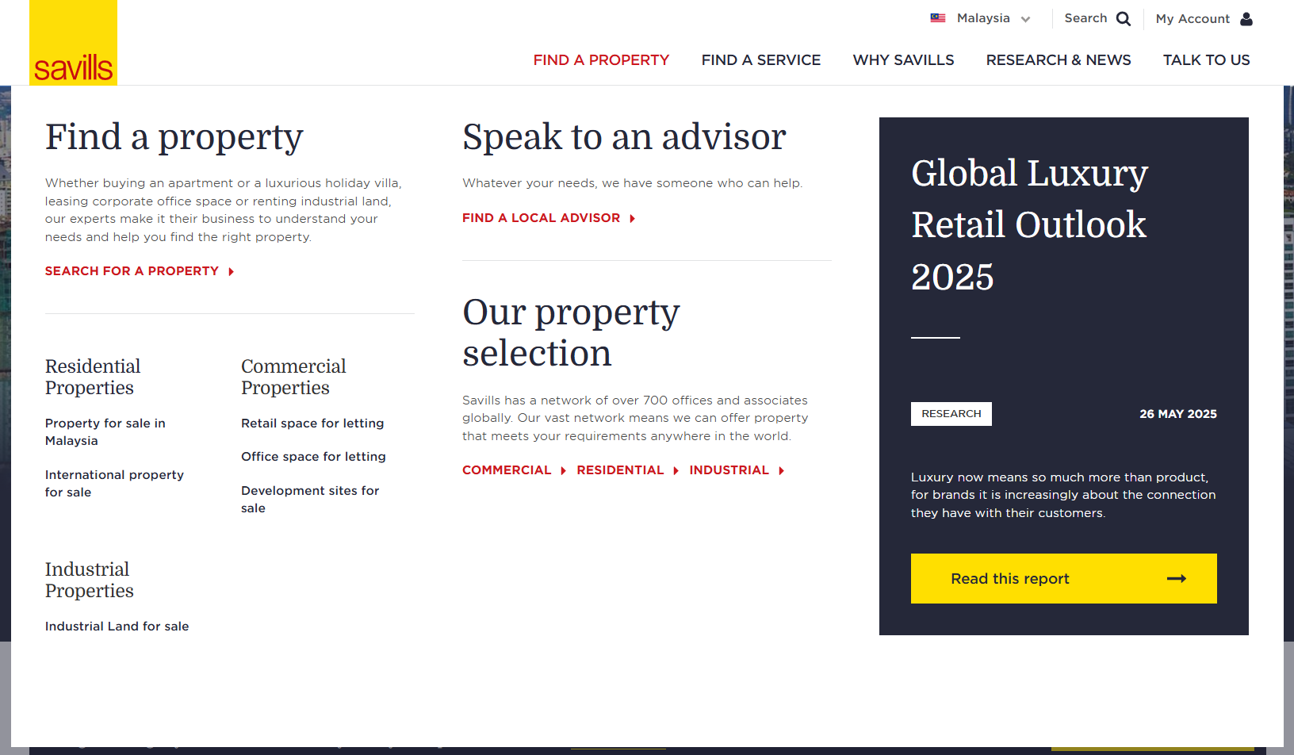
Services · Results · Where We Work · Why LCAS · Contact
[Title]
---
[body text]

[button]

LCAS logo
[Group 1]
Warehousing
Network Strategy
3PL Selection
Transport
Inventory
Cost-to-Serve
OpEx
M&A
[Group 2]
Xxx
Xxx
Xxxx
Xxxx
Xx
X
X
Xx
Xx
x
[Title]
[body text]
[link] [link] [link]

[Title]
[body text]
[link]

[Title]
[body text]
[link]

Ref: Existing Savills website navigation bar
https://www.savills.com.my/


Expanded menu of Results
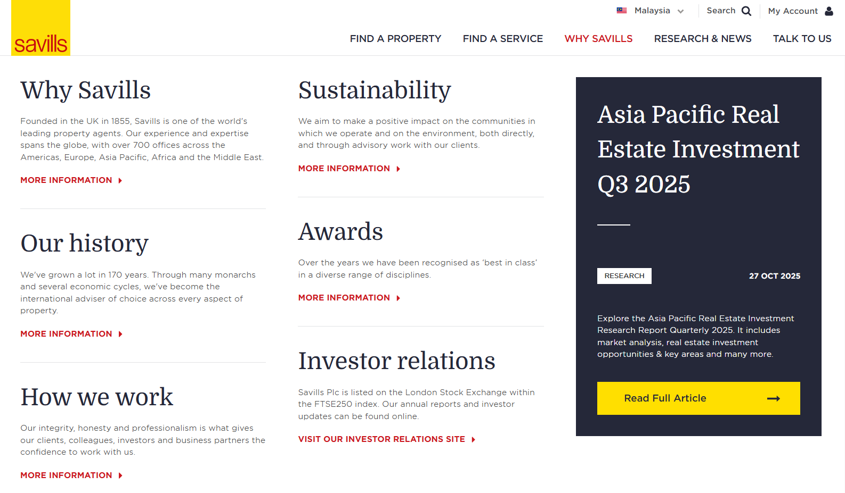
Services · Results · Where We Work · Why LCAS · Contact
[Title]
[body text]
[link] [link] [link]

[Title]
[body text]
[link] [link] [link]

[Title]
[body text]
[link]

[Title]
[body text]
[link]

[Title]
[body text]
[link]

[Title]
---
[body text]

[button]

LCAS logo
[Title]
[body text]
[link]

Ref: Existing Savills website navigation bar
https://www.savills.com.my/


Expanded menu of Where we work

Services · Results · Where We Work · Why LCAS · Contact
[Title]
[body text]
[link] [link] [link]

[Title]
[body text]
[link] [link] [link]

[Title]
[body text]
[link]

[Title]
[body text]
[link]

[Title]
[body text]
[link]

[Title]
---
[body text]

[button]

LCAS logo
[Title]
[body text]
[link]

Expanded menu of Why LCAS
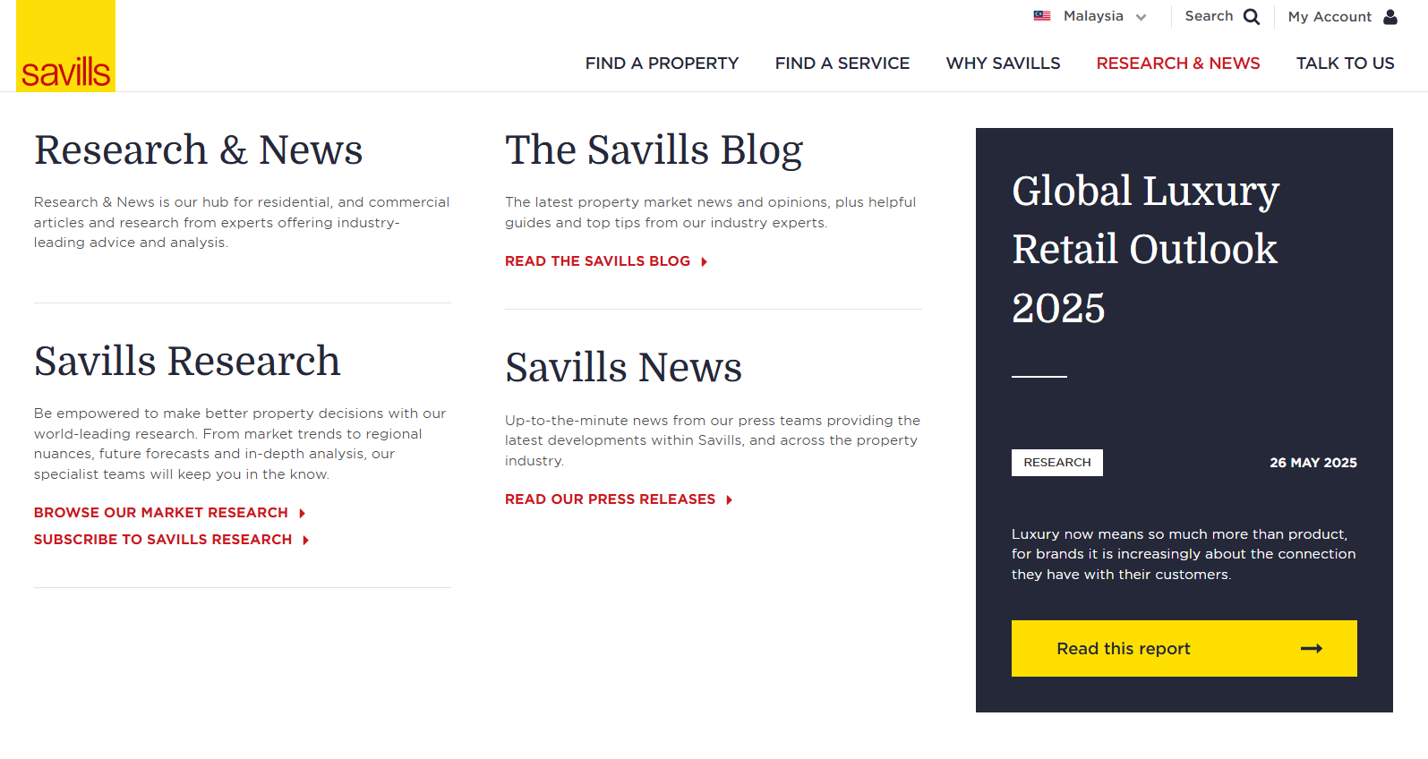
[Title]
[body text]
[link]

[Title]
[body text]
[link] [link] [link]

Services · Results · Where We Work · Why LCAS · Contact
[Title]
[body text]
[link]

[Title]
---
[body text]

[button]

LCAS logo
[Title]
[body text]
[link]

Expanded menu of Contact
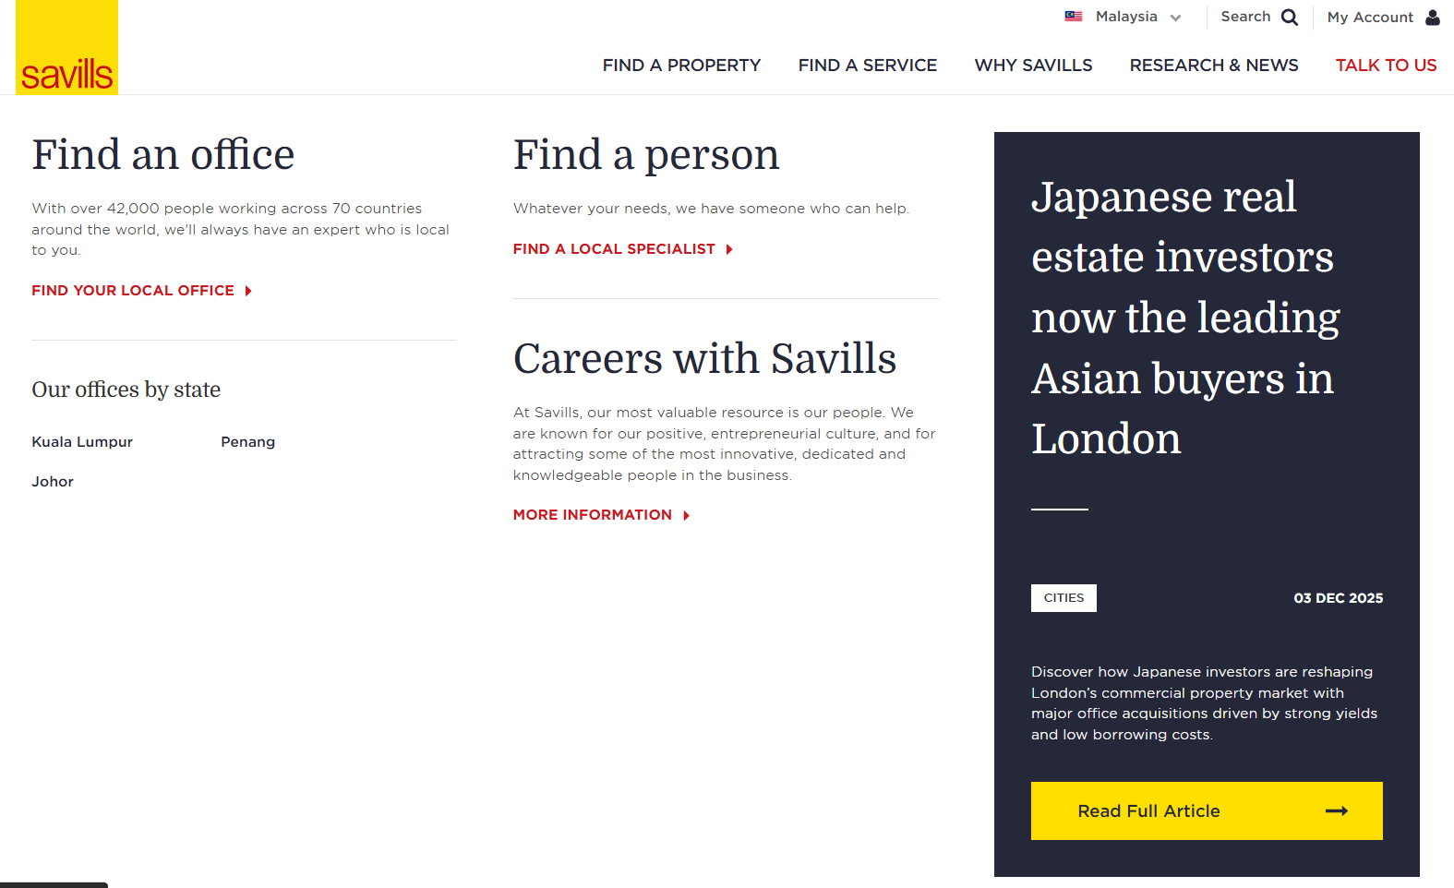
[Title]
---
[body text]

[button]

[Title]
[body text]
[link]

[Title]
[body text]
[link] [link] [link]

Services · Results · Where We Work · Why LCAS · Contact
[Title]
[body text]
[link]

LCAS logo
[Title]
[body text]
[link]

Footer
Tagline: Independent supply chain and logistics consultancy for Asia since 1999.
Services links: Warehousing · Network Strategy · 3PL Selection · Transport · Inventory · Cost-to-Serve · OpEx · M&A
Contact: Kuala Lumpur, Malaysia · +60 3 2161 1234 · info@lca.asia
Legal: © 2026 LCA Savills. All rights reserved. · Privacy · Terms · Sitemap

Independent supply chain and logistics consultancy for Asia since 1999.

Services | Talk to us
Warehousing  Network Strategy  3PL Selection  Transport  Inventory  Cost-to-Serve  OpEx  M&A | Kuala Lumpur, Malaysia.  +60 3 2161 1234  info@lca.asia

© 2026 LCA Savills. All rights reserved. · Privacy · Terms · Sitemap

Ref: Existing Savills footer
https://www.savills.com.my/
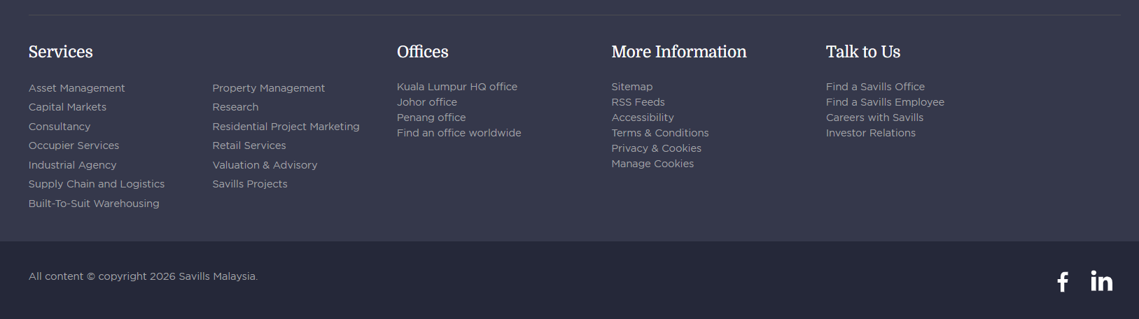

Website changes (still to do)
Prompt for AI to make changes to the webpages
The goal is to create a concept layout that gives a general idea, so it is easier for Savills team to work with, not to aim for perfection. Images can be dummy images or empty image placeholders if AI couldn’t generate it.

Global
https://dv8-ten-ac-h-ppq.vercel.app/

Navigation bar - logo

Change from original:

Change logo to:


Logo source file (please download and attach with the prompt to ai):
MY, Savills-LCA, Consulting -LCA Savills Logo_LCA Outline.png -All Documents

AI prompt:
(Feel free to amend or use your own)
Update the global navigation bar across all pages by replacing only the logo on the left side with the attached logo image. Keep the logo in the same position and ensure it is properly sized and aligned within the navbar, no margin or padding on top and bottom of the logo. Do not modify any other navigation elements—the menu items, layout, spacing, alignment, and right-side content should remain exactly as they are. The only change should be swapping the existing logo for the attached logo.

[attach logo image & screenshot of the original and chang-to image]

Homepage
https://dv8-ten-ac-h-ppq.vercel.app/

What that delivers section

Change from original:
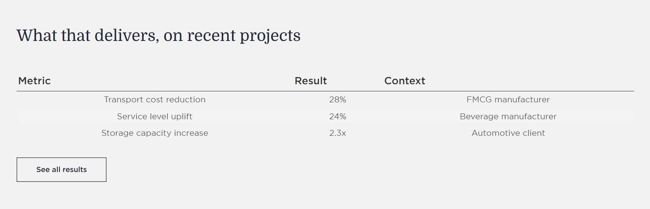

Change layout to (ignore text below):
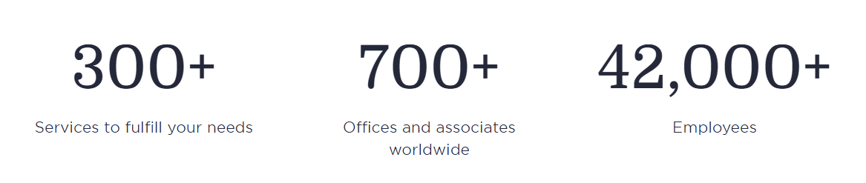

AI prompt:
(Feel free to amend or use your own)
Convert this section from a table layout into a horizontal 3-metric stats section like the reference image. Keep the title “What that delivers, on recent projects” and the CTA. Remove the table structure, headers, rows, dividers. Replace them with three evenly spaced statistic blocks displayed side-by-side in a single row. Each block should contain a large metric/value on top and a short label beneath it (e.g. “Transport cost reduction”, break another line then “FMCG manufacturer”), with all content center-aligned. Focus on matching the layout, spacing, alignment, and hierarchy shown in the reference image.

[attach screenshot of the original and change-to image above]

Warehousing, carried the whole way section

Change from original:
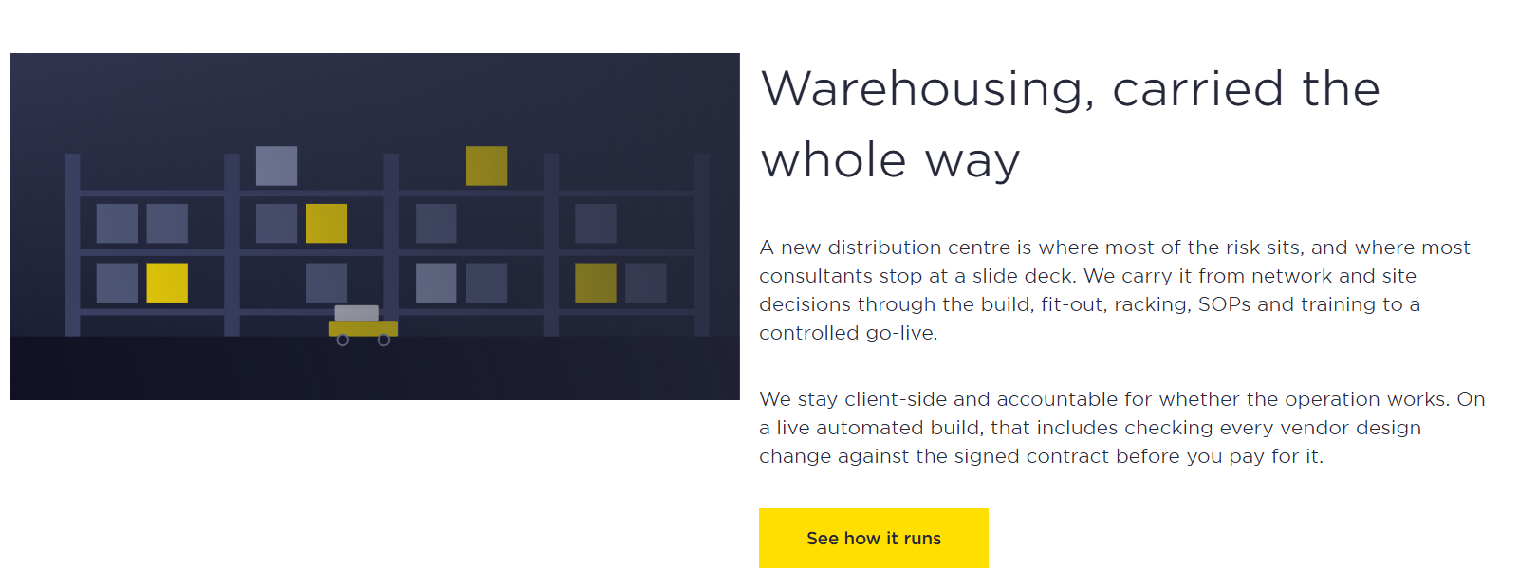

Change layout to:
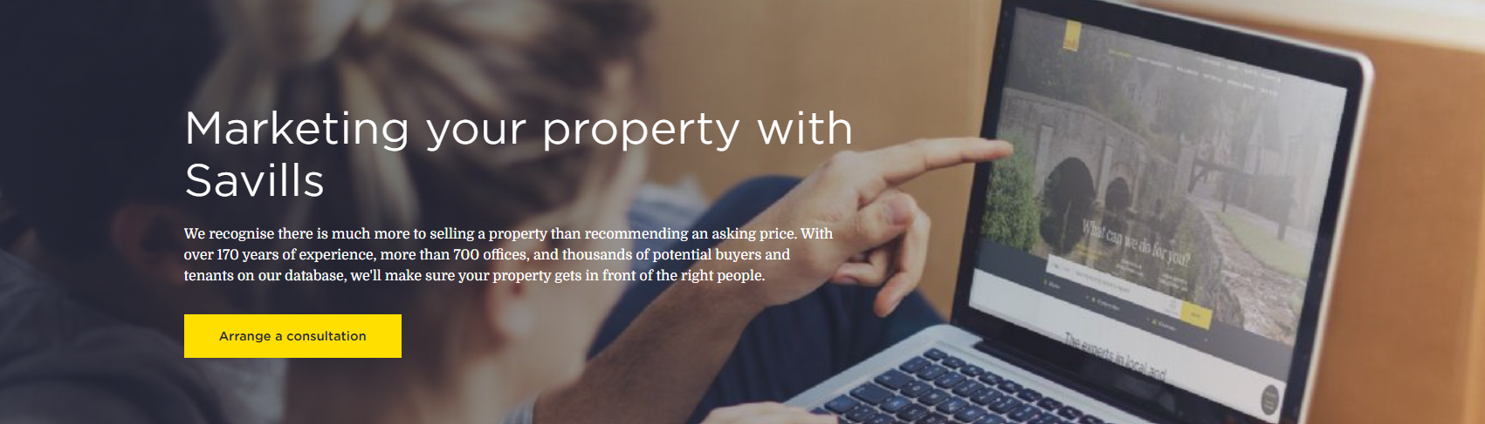

AI prompt:
(Feel free to amend or use your own)
Change this section from a two-column layout into a full-width hero/banner layout like the reference image. Replace the illustration with a large warehouse-related background image that spans the entire section width. Overlay the content on top of the image, positioning the headline, description, and CTA button on the left side. Match the overall layout, content placement, proportions, and font-size hierarchy shown in the reference image, while keeping the existing content. Focus on the structure and spacing rather than colors or exact imagery.

[attach screenshot of the original and change-to image above]

Who we work with & Focussed on Asia section

Change from original:
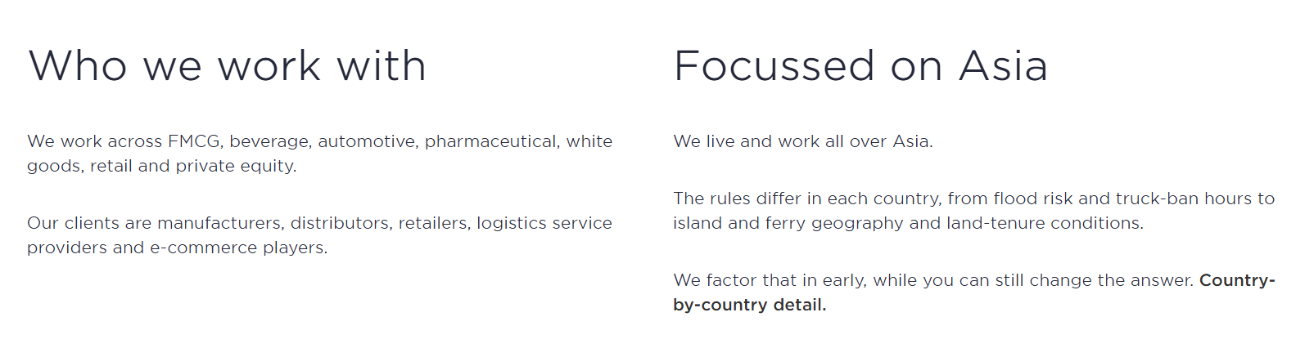

Change to layout:
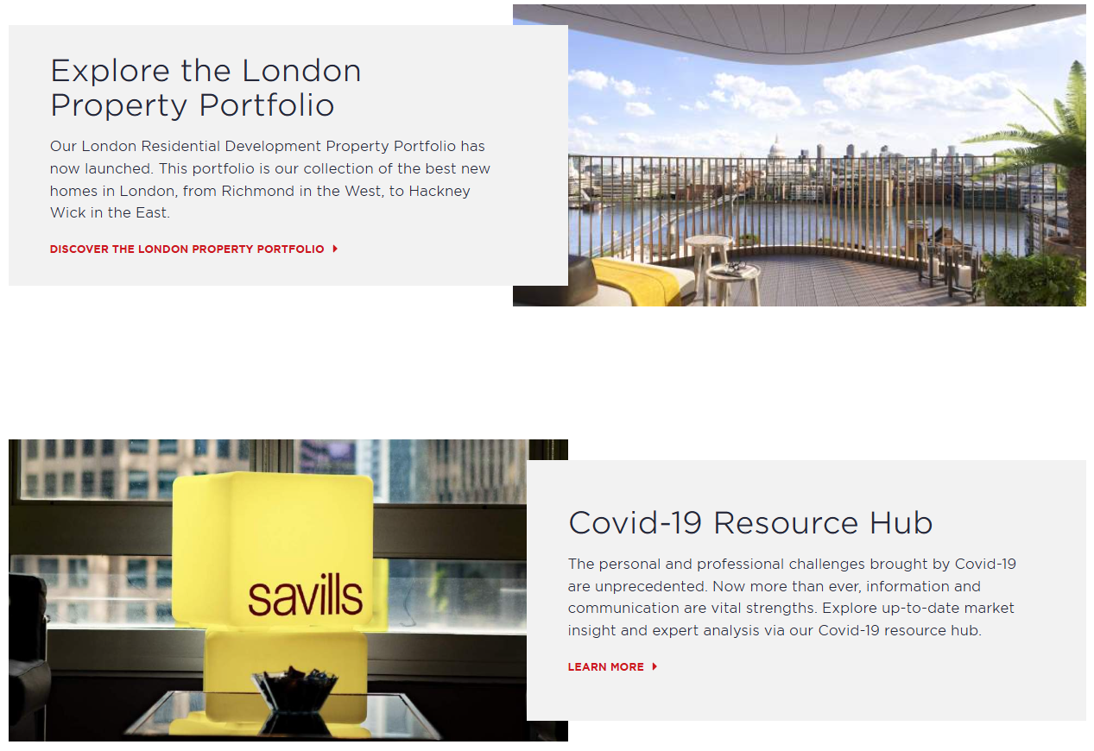

AI prompt:
(Feel free to amend or use your own)
Change this section from a simple two-column text layout into two alternating feature cards like the reference image. Each card should combine text content with a large image, using a staggered layout where the text panel partially overlaps the image. Use a relevant business, logistics, or supply chain image for each card. Convert “Country-by-country detail” into a prominent red text link styled like the reference screenshot. Also add a red “Learn more” text link to the Who We Work With section, matching the same link style and placement shown in the reference. Focus on replicating the layout structure, alternating image/text arrangement, spacing, and content hierarchy.

[attach screenshot of the original and change-to image above]

(Thoughts) BTS shout-out section

Should we add a BTS shout-out somewhere on the homepage?
Source: https://lca.asia/

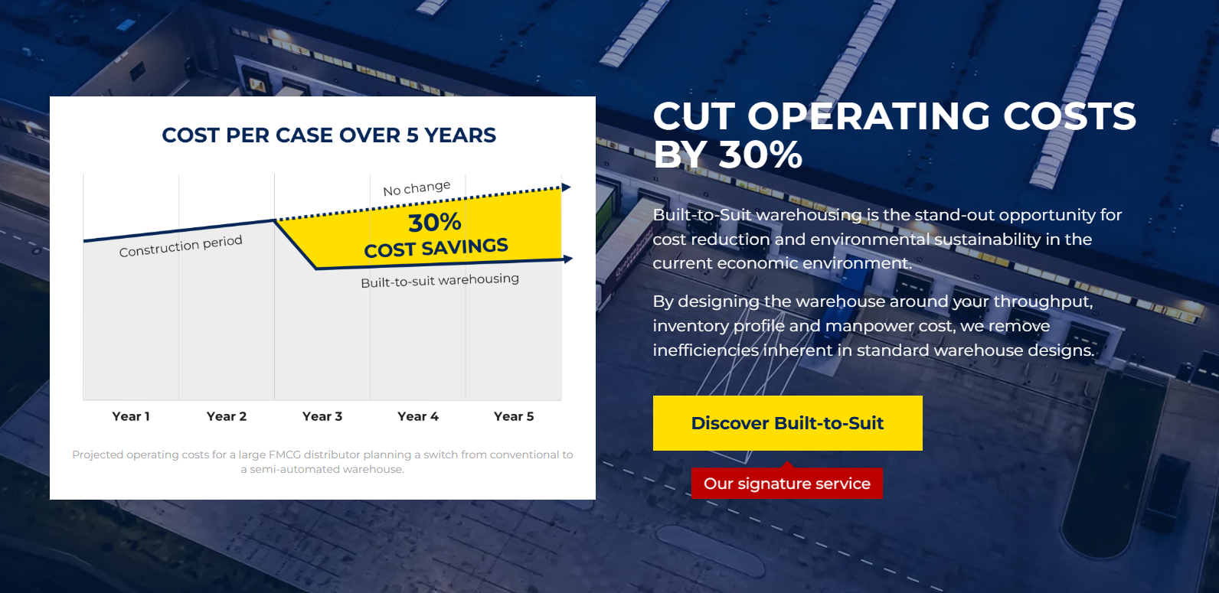

Services
https://dv8-ten-ac-h-ppq.vercel.app/services

Ways to start working with us section

Change from original:
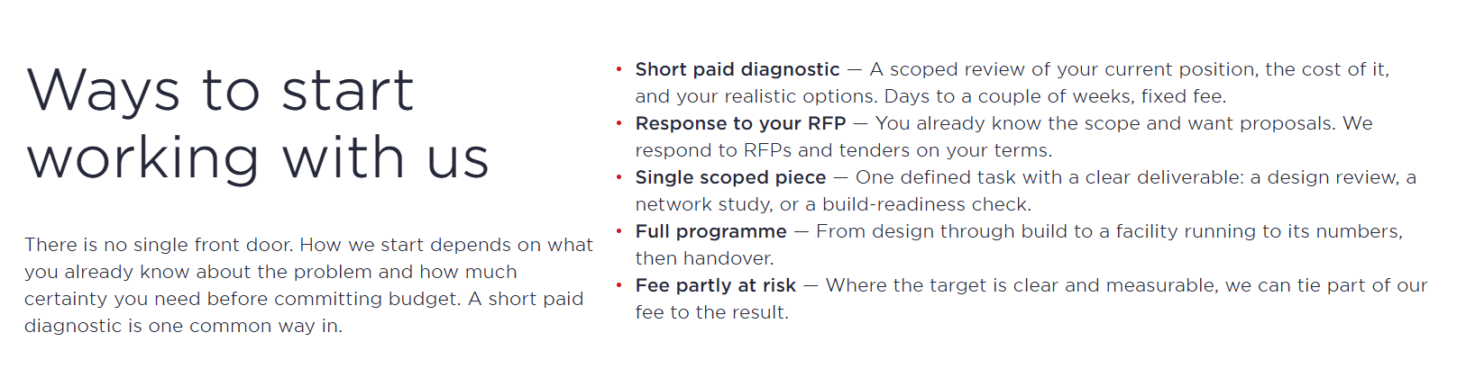

Change layout to:
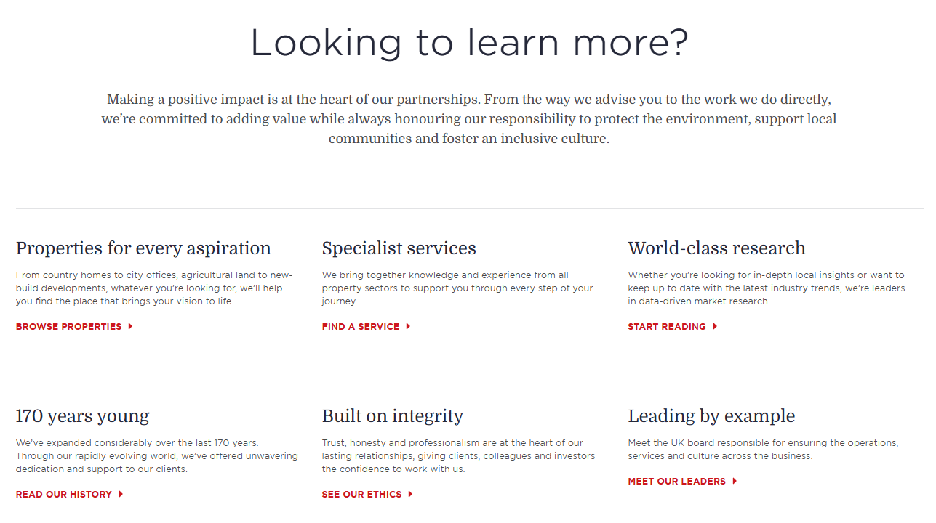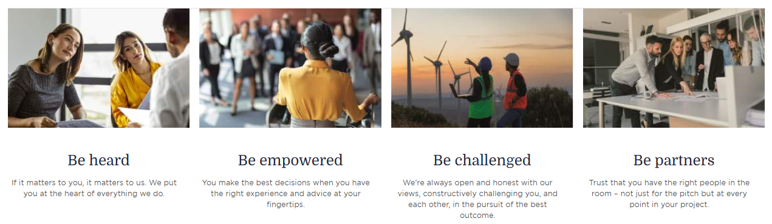

AI prompt:
(Feel free to amend or use your own)
Change this section from a two-column text layout into a centered introduction section with a row of 5 value cards beneath it, matching the reference layout. Place the main heading and introductory text centered at the top. Below, display all 5 existing content items in a single horizontal row, each with an image, title, short description. Use relevant business, logistics, warehouse, or supply chain images. Ensure all 5 cards have equal width, consistent spacing, and follow the same visual hierarchy and alignment as the reference screenshot. Focus on matching the layout structure, spacing, and card-based design rather than the exact text or imagery.

[attach screenshot of the original and change-to image above]

What hands-on… & We know the local… section

Change from original:
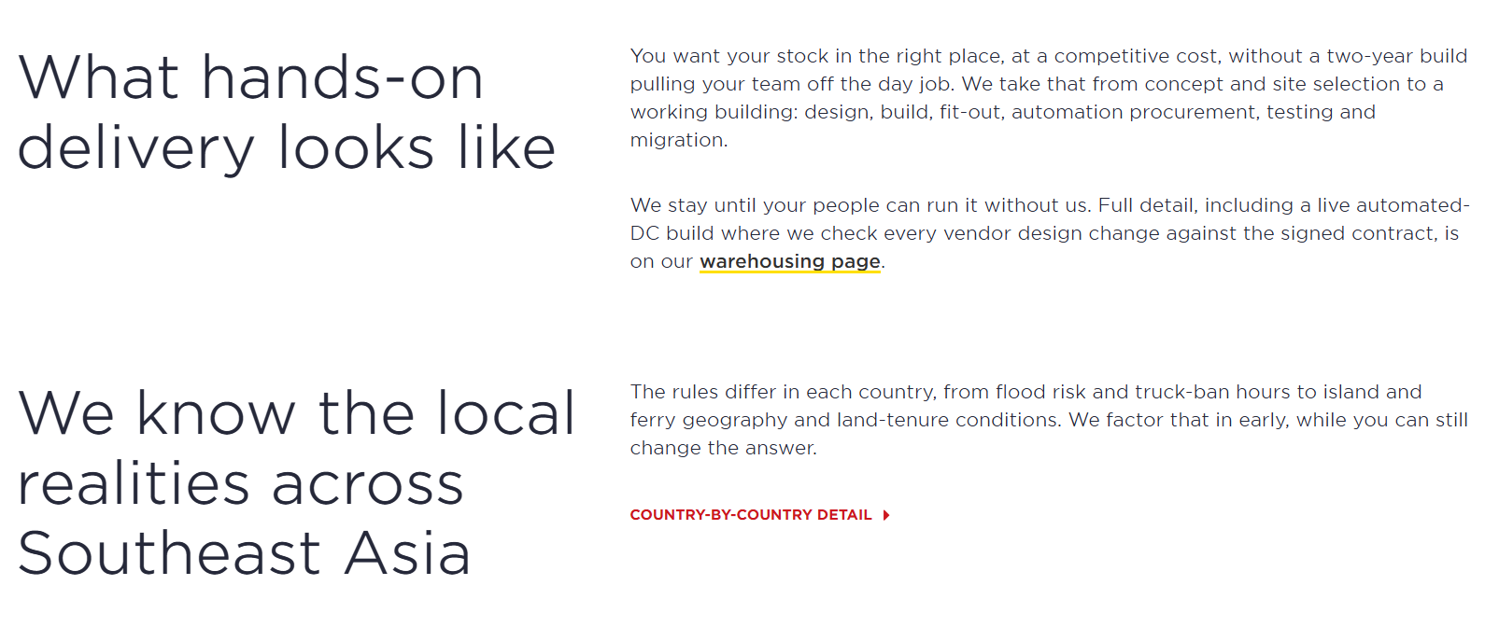

Change layout to:
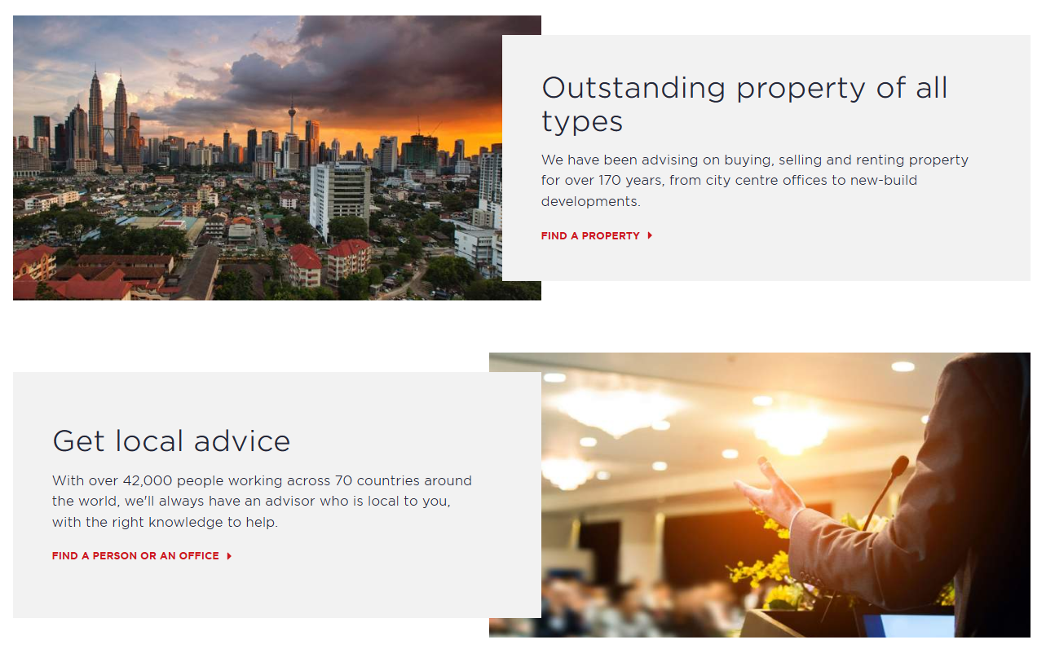

AI prompt:
(Feel free to amend or use your own)
Change this section from stacked text blocks into two alternating image-and-content feature cards like the reference layout. Reorganize the existing content into two separate rows, each combining a large image with a text panel that partially overlaps the image. Alternate the layout so the first row has the image on the left and text on the right, and the second row has the text on the left and image on the right. Use relevant Southeast Asia, logistics, warehouse, distribution, or business-related images. Keep the existing headings, descriptions, and red text links, but match the overall layout structure, spacing, proportions, overlapping card effect, and content hierarchy shown in the reference screenshot. Remove the link from the text “warehousing page” and create it as a red link instead, with the text “Learn more about our warehousing”.

[attach screenshot of the original and change-to image above]

Services – inner pages
https://dv8-ten-ac-h-ppq.vercel.app/warehousing-end-to-end

Layout for services inner pages (applies to all services inner pages)

If this can’t be done, please let me know and we’ll skip this part. I will let Savills team know we’re using this 2-column template taken from their website.
~Coco

Change from original:  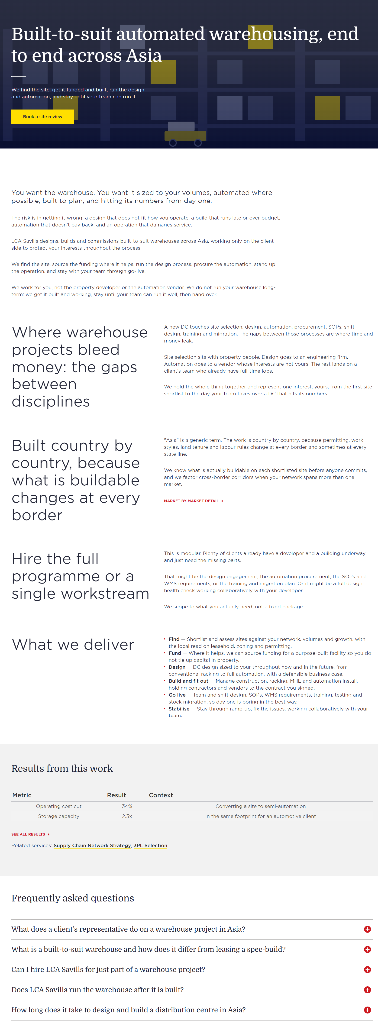 | Change layout to:  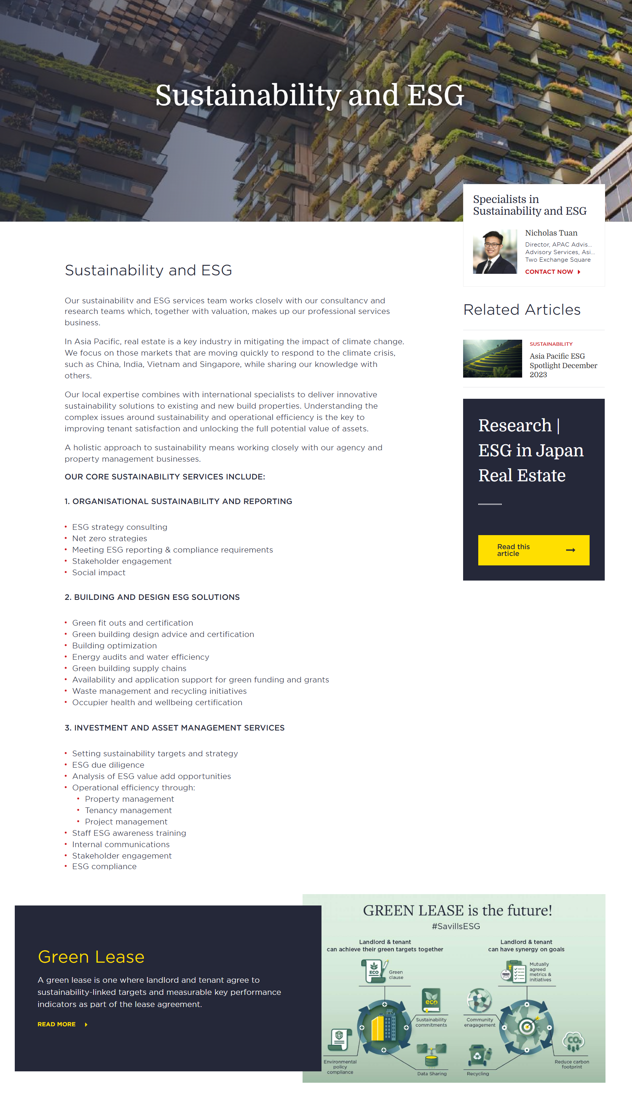

AI prompt:
(Feel free to amend or use your own)
Change this page from a single full-width content flow into a two-column page layout like the reference screenshot. Move all content from “You want the warehouse” down to and including the “What we deliver” section into the main left column. Create a narrower right sidebar column for supporting content such as links, related resources, contact information, featured content, or promotional blocks. Keep the left column as the primary content area and the right column visually separate as a sidebar. The hero section at the top can remain full width. Keep the FAQ section full width below both columns, spanning the entire page, similar to the reference layout. Focus on matching the overall two-column structure, proportions, spacing, and sidebar behavior rather than the exact content.

[attach screenshot of the original and change-to image above]

BTS page

https://dv8-ten-ac-h-ppq.vercel.app/warehousing-end-to-end

What we deliver section

Change from original:
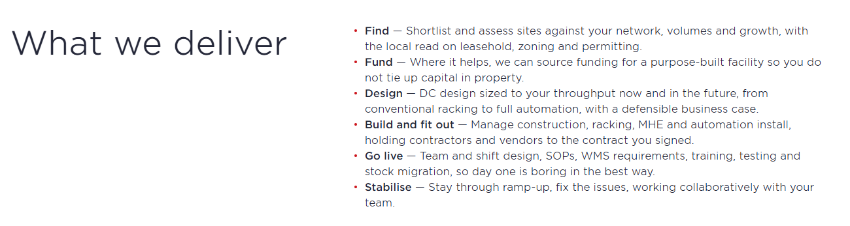

Change layout to:



AI prompt:
(Feel free to amend or use your own)
Change this section from a simple heading-and-bullets layout into a card-based content grid like the reference screenshot. Keep the existing “What We Deliver” content, but reorganize each delivery item into its own card with a relevant image, title, and short description. Display the cards in a responsive grid layout with 2 rows and 3 columns (or adjust to fit all existing items evenly). Add a left-aligned section heading above the grid and maintain consistent spacing, alignment, and visual hierarchy throughout. Use relevant warehouse, logistics, distribution, and supply chain images for each card. Focus on matching the layout structure, card design, image placement, and grid arrangement shown in the reference rather than the exact text or imagery.

[attach screenshot of the original and change-to image above]

Built country by country… section

Change from original:
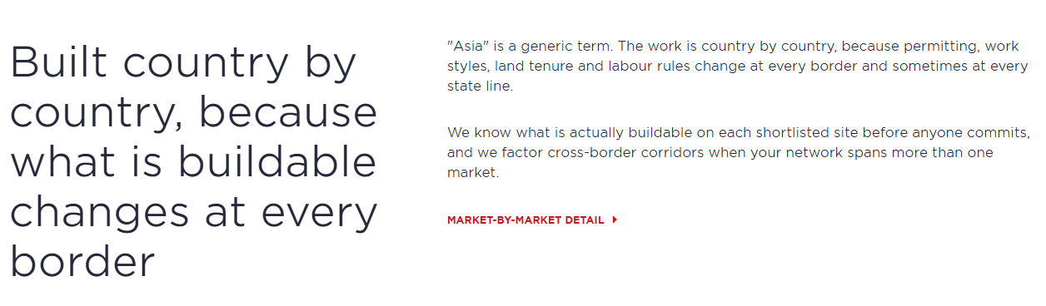

Change layout to:


AI prompt:
(Feel free to amend or use your own)
Change this section from a two-column text layout into a full-width hero/banner section like the reference screenshot. Use a large background image related to cross-border logistics, Southeast Asia, warehousing, or regional infrastructure that spans the entire section width. Overlay the existing heading, supporting text, and red link on top of the image, positioning them on the left side. Change the red link into the CTA button. Maintain a clear text hierarchy with the headline as the primary focus, followed by the description and CTA button. Focus on matching the layout structure, content placement, spacing, and proportions of the reference image rather than the exact image.

[attach screenshot of the original and change-to image above]

Results from this work section

Change from original:
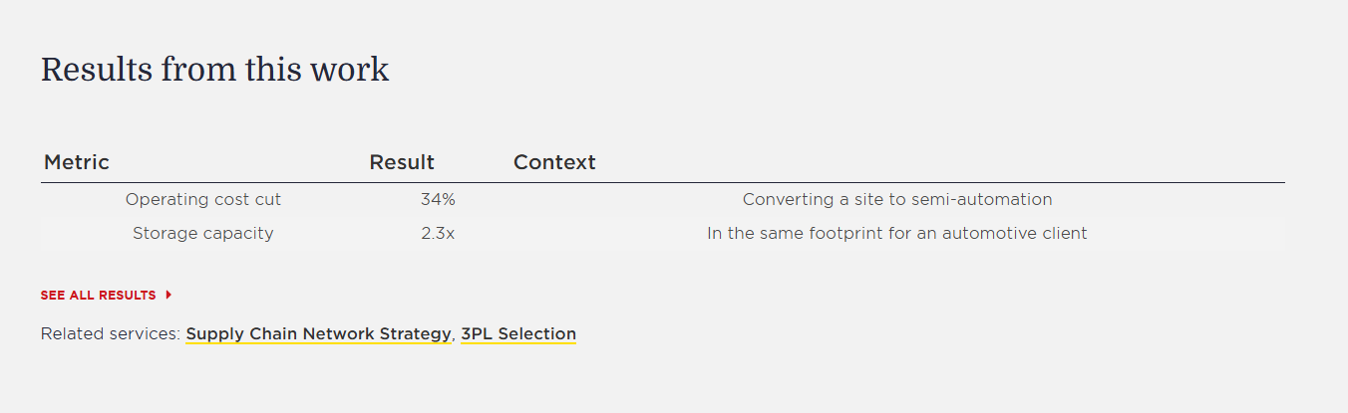

Change layout to:


AI prompt:
(Feel free to amend or use your own)
Convert the table layout into a horizontal 2-metric stats section like the reference image. Remove the table structure, headers, rows, dividers. Replace them with 2 evenly spaced statistic blocks displayed side-by-side in a single row. Each block should contain a large metric/value on top and a short label beneath it (e.g. “Operating cost cut”, break another line then “Converting a site to semi-automation”), with all content center-aligned. Focus on matching the layout, spacing, alignment, and hierarchy shown in the reference image.

[attach screenshot of the original and change-to image above]

Results
https://dv8-ten-ac-h-ppq.vercel.app/results

Case studies by sector section

Change from original:
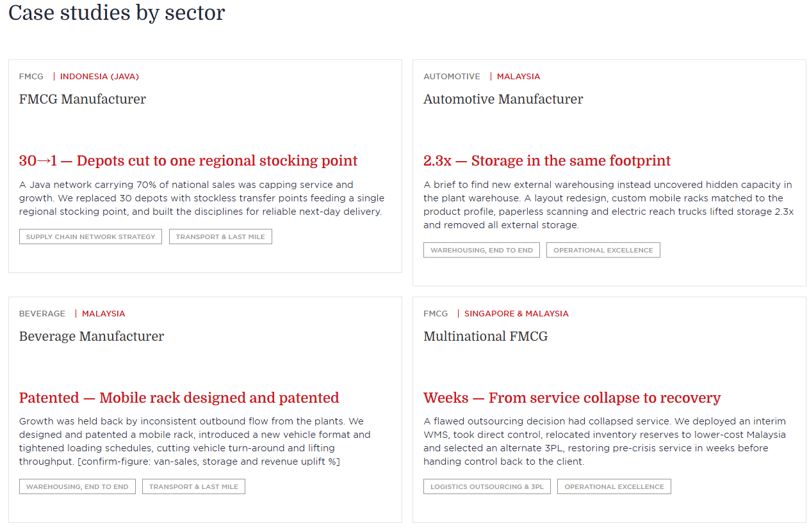

Change layout to:
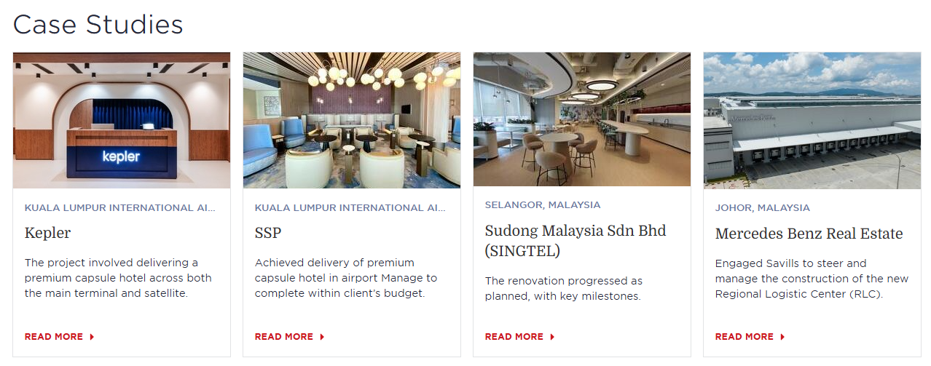

AI prompt:
(Feel free to amend or use your own)
Change the Case Studies section layout from 4 rows × 2 columns into 2 rows × 4 columns, matching the reference screenshot. Keep all 8 existing case study cards, but display them in a wider grid with 4 cards per row and 2 rows total. Add a relevant featured image to each card, positioned at the top, similar to the reference design. Each card should follow the same structure: image, category/location, title, short description, and CTA link. Ensure all cards have equal dimensions, consistent spacing, aligned content, and a clean card-based appearance. Focus on matching the grid arrangement, image placement, proportions, and visual hierarchy shown in the reference layout.

[attach screenshot of the original and change-to image above]

Why LCAS
https://dv8-ten-ac-h-ppq.vercel.app/why-lca

Five reasons… section

Change from original:
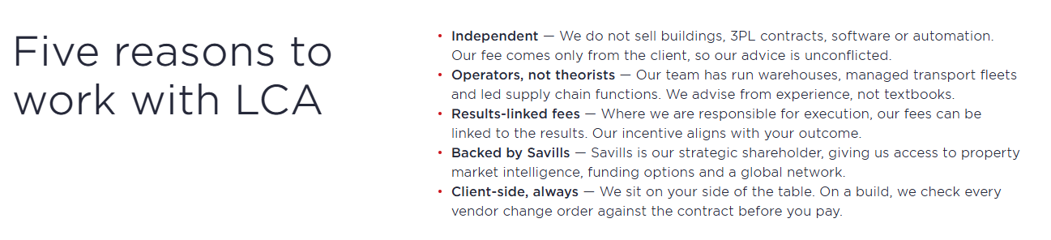

Change layout to:


AI prompt:
(Feel free to amend or use your own)
Change this section from a two-column heading-and-bullet layout into a 5-card value proposition section like the reference screenshot. Create a centered section heading at the top, then transform each of the five reasons into its own card displayed in a single horizontal row. Each card should include a relevant business, logistics, warehouse, or consulting-themed image at the top, followed by the reason title and a short description. Use all 5 existing reasons as separate cards, ensuring equal card widths, consistent spacing, aligned content, and a clean card-based layout. Focus on matching the structure, image placement, proportions, and visual hierarchy shown in the reference layout.

[attach screenshot of the original and change-to image above]

The team section

We might remove this section entirely because of John’s concern.
John, please confirm.

